Facemask Sewing Instructions
Based on the pattern by Jessica Nandino

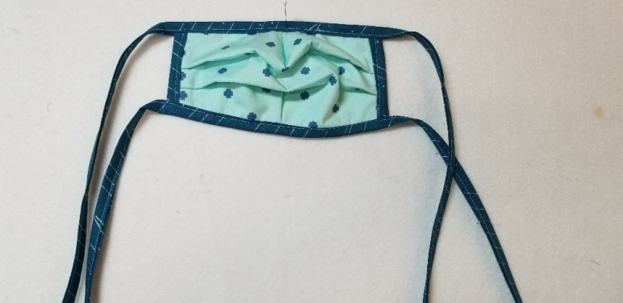

Materials Needed: This works for either size mask
¼ yard for facemasks
¼ yard for ties
¼ yard non-woven interfacing (optional)
Thread

Cutting Instructions-Be sure that the scale square on the pattern measures one inch—you may have to size the pattern up or down with your printer.
Cut 4 facemask patterns from each ¼ yard (large or small) On the small mask pattern it shows cutting out the V’s for the darts. I don’t do this.
Cut 5) 1 ½” width of fabric strips for ties and binding
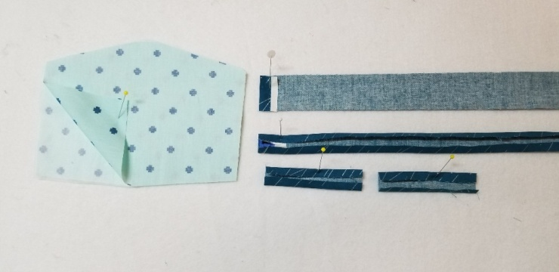
Preparing to Sew
Mask If you are using fusible interfacing, iron to the wrong side of one of the facemask pieces. If you are using sew-in interfacing, place on the wrong side of one of the facemask pieces.
Ties: Turn down and press the ends of the ties about a ½”. Next fold and press ¼” on the wrong side of the ties the full length of the fabric. Repeat for the other side. Make 2 ties for each mask.
Binding: Take the 5th strip and prepare the same as the ties, cut into 4” lengths. Save the rest for more masks.

Sewing Instructions: All seams are ¼”
- Lay the interfaced mask piece facedown on a table. Place another mask piece face down on top of your first piece.
- Stitch the sides of the mask to hold it together.
- Pleats: At the ironing board, turn the mask right sides up. Create the pleats by folding and pressing. I make 2 pleats on the small mask and 3 pleats on the large mask. The goal is to have the sides measure 3” once the pleats are in. Remember: Finished, not perfect.
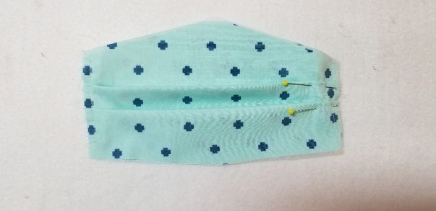
- Pin the pleats. And stitch.

20525 Broadway Sonoma, CA 95476 707.938.7312
www.broadwayquilts.com

- Binding: Take one of the 4” binding pieces, open up one side and place right sides together, even with the raw edges of the mask. Stitch
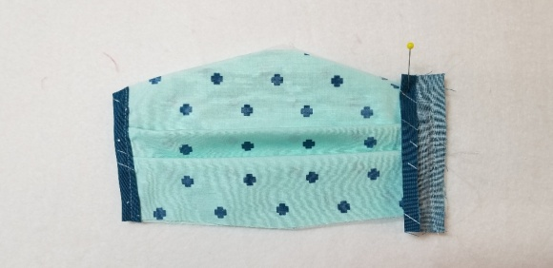
- Turn over. Fold the binding up and over the edge of the mask and stitch in place. Repeat on the other side. Trim

- Darts: Fold the mask right sides together and mark the darts. (If you don’t have a fabric marking marker, lightly use a pencil.)This creates the fit for the nose and the chin. Stitch from the raw edge to the point. Stop. Backstitch back up your stitching to the raw edge where you started. Repeat for both darts.
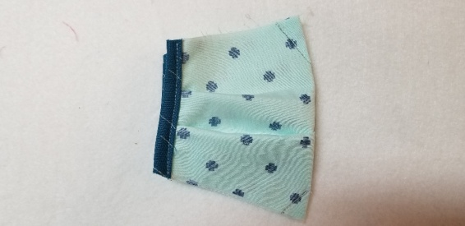

- Ties: Hold up the ties, fold them in half and mark the center with a pin or by pinching a crease.
- Open up the tie on one side and pin the right side center tie to the right side of the mask at the dart.
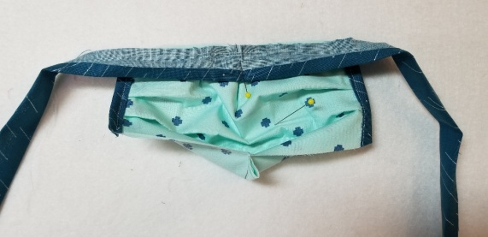
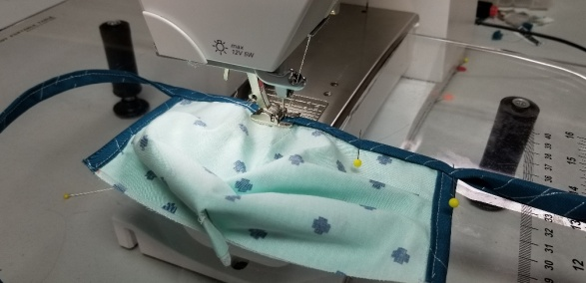

- Stitch the tie to the mask. Start at the edge of the mask, over the center to the other edge.
- Turn the mask, so that the wrong side of the mask is facing up. Fold the edges of the tie in half.
- Stitch from one end of the tie, across the mask and to the end of the tie.
- Repeat for the other side. Your mask is finished!

Take good care, Gery

20525 Broadway Sonoma, CA 95476 707.938.7312
www.broadwayquilts.com

