Gourmet Sewing Club
July 2019
Project: Clam Up

Pattern: Clam Up by annie.com
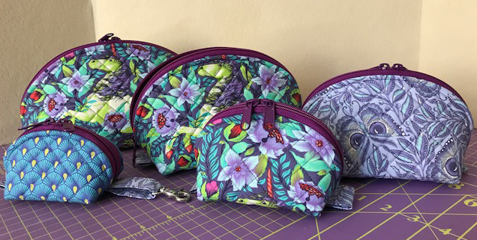

Fabric/Supplies needed: I suggest making a Medium or larger for first pouch.

Supplies | XS | S | M | L | XL
Main Fabric | Fat 8th | Fat 8th | Fat Qtr | Fat Qtr | Fat Qtr
Lining Fabric | Fat 8th | Fat 8th | Fat Qtr | Fat Qtr | Fat Qtr
Coordinating Fabric | One Fat 8th for any one of these bags
Foam | One 18” x 58” piece will make all five bags
Handbag Zippers* | 15” or longer | 15” or longer | 20” or longer | 20” or longer | 24” or longer
Template plastic or freezer paper | 10”x8” | 12”x9” | 14”x11” | 17”x12” | 18”x14”
*Pattern designed to use handbag zippers with a wider tape.

Bring to Class:
- Sewing machine with power cord and foot control, cleaned and in good working order with a new Microtex 80/12 or 90/14 needle.
- ¼” presser foot (Bernina #37), Walking foot for quilting, a Teflon foot or walking foot is helpful if sewing on vinyl
- Basic sewing kit to include: fabric marking pen or pencil, ruler, scissors for clipping threads, shears, pins and seam ripper; sewing clips, stiletto or Purple Thang
- Rotary cutter with a new blade, mat for use with rotary cutting tool and ruler
- If using iron on vinyl laminate note pattern back for amount needed
- If adding a hook to your pouch, bring a ½” swivel hardware

Pre-Class Preparation: You will get closer to a finished pouch if you do the following
- Cut and label pattern pieces.
- If quilting, quilt outside pieces.

