Santa & Mrs. Claus are Coming to Bancroft
Lighting of Teuscher Square
Monday, December 1, 2025
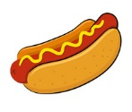
6:00 pm
 95 S. Main St. Bancroft

Caribou MEMORIAL HOSPITAL will be serving hot dogs and hamburgers to raise funds for the Bancroft fire department. Please support their effort

Enjoy traditional music,
Hot Cocoa, Sugar Cookies, Ginger Snaps,
Homemade Donuts & Fireworks-Free of Charge
There will be Fireworks ~ Please contain anxious pets
