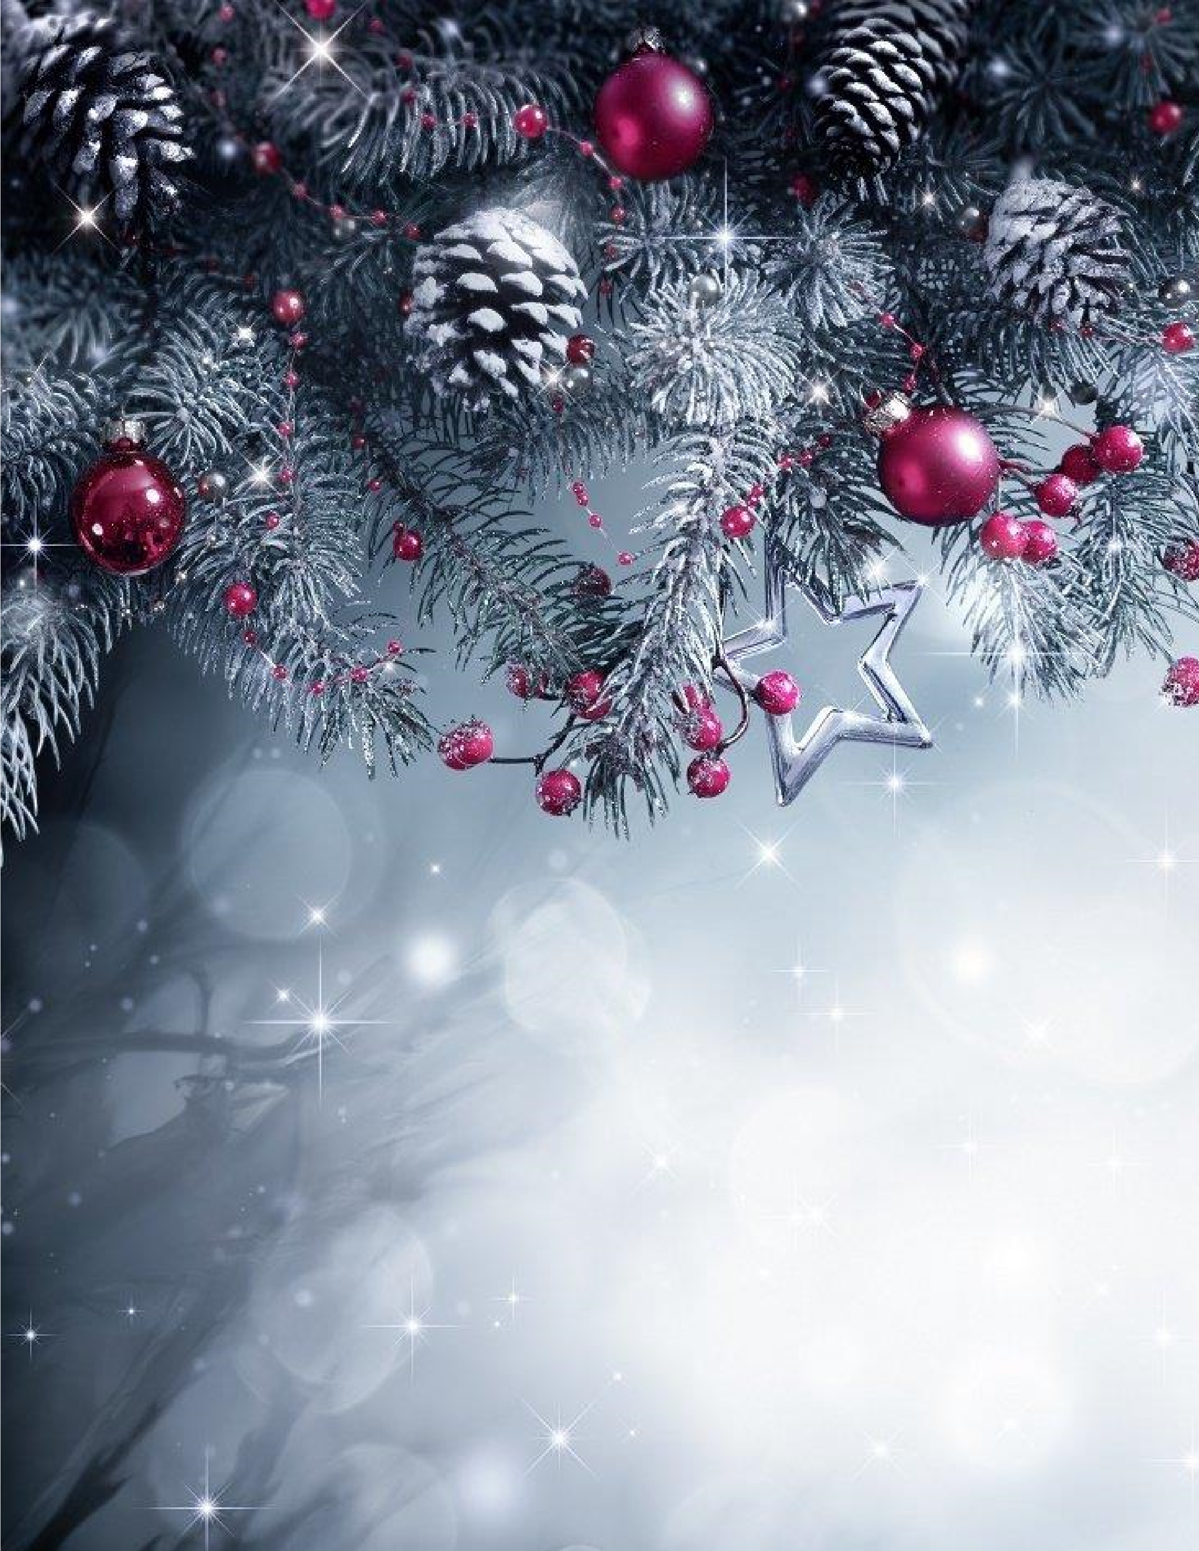

Santa
Claus

is

COMING

to

BANCROFT

COMMUNITIES ARE WEL
COME
All

PLEASE
JOIN US FOR THE

LIGHTING OF TEUSCHER
Square

Monday,
December 1
,
202
5

at
6:00

pm

95

South

Main
S
t
.

Bancroft

Come enjoy
T
raditional Christmas
M
usic
,

H
ot
C
ocoa,
S
ugar
C
ookies
, Ginger Snaps

&

H
omemade
S
pudnuts

(
No Charge
)

