City of Bancroft
Building Permit Application

The undersigned hereby makes application for permit to develop in the City of Bancroft. The work to be performed is described below and in attachments hereto. The undersigned agrees that all such work shall be done in accordance with the requirements of the City of Bancroft and with all other applicable local, State and Federal regulations. This application does not create the liability on the part of the City of Bancroft or any officer or employee thereof for any damages which may occur from the developing process, demolition, or any flood damages that result from reliance on this application or any administrative decision made lawfully there under. Items that are not applicable to your project can be left blank.
Property Owner _____________________________________ Phone: _____________________

Owner Address: __________________________________________________________________

Builder: ____________________________________ Phone: ____________________________

Development Site Address: __________________________________________

Subdivision _______________________ Lot _______ Block _______________________

Estimated Cost of Project $ __________________________

Est. Project Start Date ________________________ Est. Project End Date ___________________

Will this alternation or reconstruction project require demolition: _________________ (YES OR NO)
Square footage of the Existing Structure ___________________
Proposed square footage of New Construction _____________
Proposed Development Description
New Building | Improvement to existing Building
Manufactured home Other | Filling
Description of Proposed Project:

Permit Approved By: __________________________________ Date: ___________

Other Permits

Have all state and local permits been obtained? O Yes O No
What permits have been obtained (list below) _______________________________________________________________________________
_______________________________________________________________________________
Were the permits approved or denied? (circle one) APPROVED DENIED
Is the proposed development in a flood zone? ________ (see city maps)
Base Flood Elevation at the site feet NGVD _____________
Required lowest floor elevation (including basement _____________
Elevation to which all attendant utilities, including all heating and electrical equipment will be protected from flood damage NGVD _______________________
Type of Flood Proofing methods ______________________________________________________________________________________
Required flood proofing elevation is ____________________
Flood proofing certification by a registered engineer is attached YES or NO
If yes, does the plat or proposal clearly identify the base flood elevations YES or NO
Please attach additional information on a separate piece of paper.
Elevation Certificate Attached O Yes O No
As-Built Lowest floor elevation: Feet NGVD Plans are drawn to scale? O Yes O No
Work was inspected by: _________________________________________
Conditions:

Market value

This Permit is intended to conform to the City of Bancroft zoning ordinance and Federal Regulations as set by the Federal Emergency Administration (FEMA) for areas within a designated floodplain.

FEES
Projects Costing up to $1 ,000 = $10.00
For each additional $10,000=$10.00
Example:
- A project costing $500.00 would require a $10.00 permit fee.
- A project costing $2,000.00 would require $10.00 for the 1st $1,000.00 and an additional $10.00 for the next $10,000.00.
- A project costing $51,000.00 would require $10.00 for the 1st $1,000 and $50.00 for the remaining $50,000.00 of the project.
Appeals to Planning and Zoning Committee $5.00
Appeals to Change Zoning Map $25.00 Processing Fee
Inspection Fees are not included in the permit fee if project extension is required

PLOT PLAN
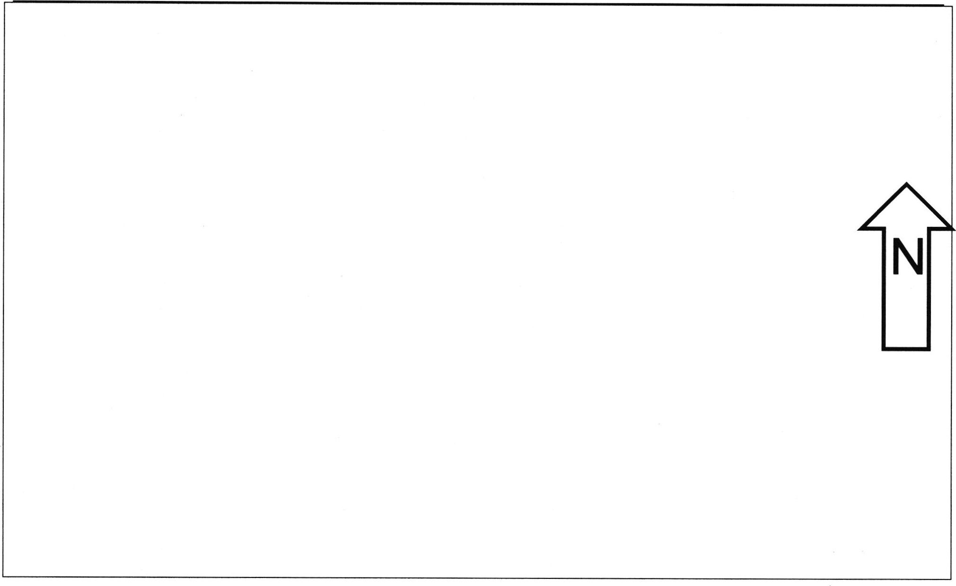
Residential Setbacks: See City Codes at www.bancroftcity@icsofidaho.net
I hereby certify that I have read and examined this application and know the same to be true and correct. All provisions of laws and ordinances governing this type of work will be complied with whether specified herein or not. The granting of a permit does not presume to give authority to violate or cancel the provisions of any other State of local law regulating construction or the performance of construction. I also hereby authorize access to property and/or structures for the purpose of inspections and verification of information herein.
APPLICANT SIGNATURE: ________________________________ DATE: _____________

APPROVED BY: (auth official) _____________________________ DATE: ___________

