THE PORTFOLIO TOTE
Class Info and Supply List

Teacher: Mary Lou

4233 West Thunderbird Road, Phoenix, AZ 85053 602-843-1554

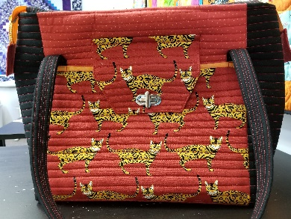

Dates –Weekday sessions: 9:15 A.M. on Wednesday

July 21, 2021 and July 28, 2021
Weekend sessions: 11:30 a.m. on Sunday

July 25, 2021 and August 1, 2021

Class Supply List
- Pattern: The Portfolio Tote by Penny Sturges
- Fabrics:
  - 1 ½ yards for the outside.
  - 1 yard for outside pockets
  - 1 yard for accent
- Light fusible fleece: 1 yard
- Bosal Foam one sided fusible: 1/2 yard
- Bosal Craf-Tex Stabilizer: 2 pieces 5” x 16”

- Zipper: 24” Separating Zipper
- Thread: for piecing, topstitching and quilting as well as some hand-sewing.
- Rulers:
- 6 ½” x 24 ½” or 8 1/2” x 24 ½”
- Purse hardware: 1 turnlock
- Optional accessories: Purse feet, Snap closer, etc
- Helpful tools:
- Small screw driver kit
- Fabric Glue such as “Unique Stitch”
- .
- OTHER TOOLS: Walking foot, heavy duty needles (Jean) size 14 or 16, large hand sewing needle, binding clips, removable fabric markers, large pins with flat heads, sewing machine, scissors, rotary cutter and large mat, seam ripper, sewing machine.

TOQS Class Rules and Requirements
- Reservations are required for all classes!
- Payment for the initial class is required at the time of reservation!
- Cancellation: If you have to cancel your participation in a class and are able to provide 24 hour notice you will receive a voucher for your class fee, which is good for use against a future class. If you cancel the day of class you will receive a voucher for 1/2 of the class fee, which is good for use against a future class. If you are a no show or cancel after the course has started, then no refund is available. There is no refund for classes taught by visiting teachers or for quilt retreats.
- Please note the classrooms of TOQS are "Fragrance Free" zones.
We have folks that are allergic, receiving medical treatment, are on oxygen or simply are just highly sensitive to scented soaps, lotions, perfumes and colognes. Therefore, for the sake of these quilters, please do not apply scented lotions, perfumes, body sprays or cologne prior to class.

