4233 West Thunderbird Road, Phoenix, AZ 85053 602-843-1554

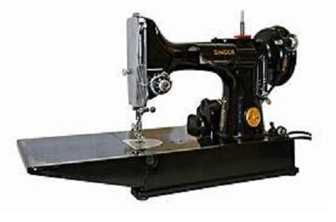
Featherweight Tips and Tricks

Class Dates and times –

Tuesday October 26, 2021 from 1:45 pm to 5:45 pm.

Required Supplies: Items From Home:
- Featherweight Shop Tune Up Kit(available from The Other Quilt Shop), including the following items:  - Sewing machine oil  - Sewing machine grease (lube)  - Tubes for cleaning motor ports  - Replacement felt drip pad  - Replacement sewing machine belt (if needed)  - Replacement LED light bulb | - Old towel for covering work surface  - Old t-shirt cut into rag sized pieces  - Q tips  - Sewing machine screw drivers  - Long shank flat head screwdriver  - Featherweight machine  - Bobbin case  - Bobbin  - Thread  - Spool stand  - Scrap fabric

TOQS Class Rules and Requirements
- Reservations are required for all classes!
- Payment for the initial class is required at the time of reservation!
- Cancellation: If you have to cancel your participation in a class and are able to provide 24 hour notice you will receive a voucher for your class fee, good for use against a future class. If you cancel the day of class you will receive a voucher for 1/2 of the class fee, good for use against a future class. If you are a no show or cancel after the course has started, then no refund is available. There is no refund for classes taught by visiting teachers or for quilt retreats.
- Please note the classrooms of TOQS are "Fragrance Free" zones.
We have folks that are allergic, receiving medical treatment, are on oxygen or simply are just highly sensitive to scented soaps, lotions, perfumes and colognes. Therefore, for the sake of these quilters, please do not apply scented lotions, perfumes, body sprays or cologne prior to class.
- Cell Phones: We ask that cell phones be silenced or on vibrate as to not disturb other students. If you need to talk a call, we understand and ask that you step out of the classroom while on the phone. Thank you!

