4233 West Thunderbird Road, Phoenix, AZ 85053 602-843-1554

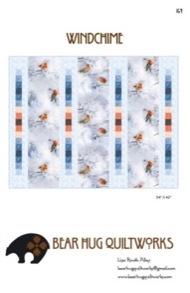

Windchime
Class Info and Supply List

Quilt Size per Pattern: 54" x 42"
Quilt Size per Sample: 62” x 50”
Shop Sample

Pattern

Class Dates and Times –

Wednesdays - October 14 and 21, 2020. All classes are 9:15 am to 1:15 pm.

Pattern: Windchime by Bear Hug Quiltworks

Fabrics per pattern NOTE: The sample quilt includes a 4" finished border, for a quilt size of 62" x 50". Please purchase an additional 3/4 yard of border fabric. If making the quilt exactly as the pattern without borders, the quilt size is 54" x 42".

Standard sewing tools:  - cutting mat  - rotary cutter  - straight pins  - seam ripper  - pencil  - thread  - glue stick  - Post-It Notes for labeling pieces  - Sewing machine with accessories and owner’s manual | Rulers:  - 6 ½” x 24 ½”  - 6 ½” x 12 ½”  - QCR Mini Ruler (QCRM)

TOQS Class Rules and Requirements
- Reservations are required for all classes!
- Payment for the initial class is required at the time of reservation!
- Cancellation: If you have to cancel your participation in a class and are able to provide 24 hour notice you will receive a voucher for your class fee, good for use against a future class. If you cancel the day of class you will receive a voucher for 1/2 of the class fee, good for use against a future class. If you are a no show or cancel after the course has started, then no refund is available. There is no refund for classes taught by visiting teachers or for quilt retreats.
- Please note the classrooms of TOQS are "Fragrance Free" zones.
We have folks that are allergic, receiving medical treatment, are on oxygen or simply are just highly sensitive to scented soaps, lotions, perfumes and colognes. Therefore, for the sake of these quilters, please do not apply scented lotions, perfumes, body sprays or cologne prior to class.

