

4233 West Thunderbird Road, Phoenix, AZ 85053 602-843-1554
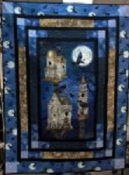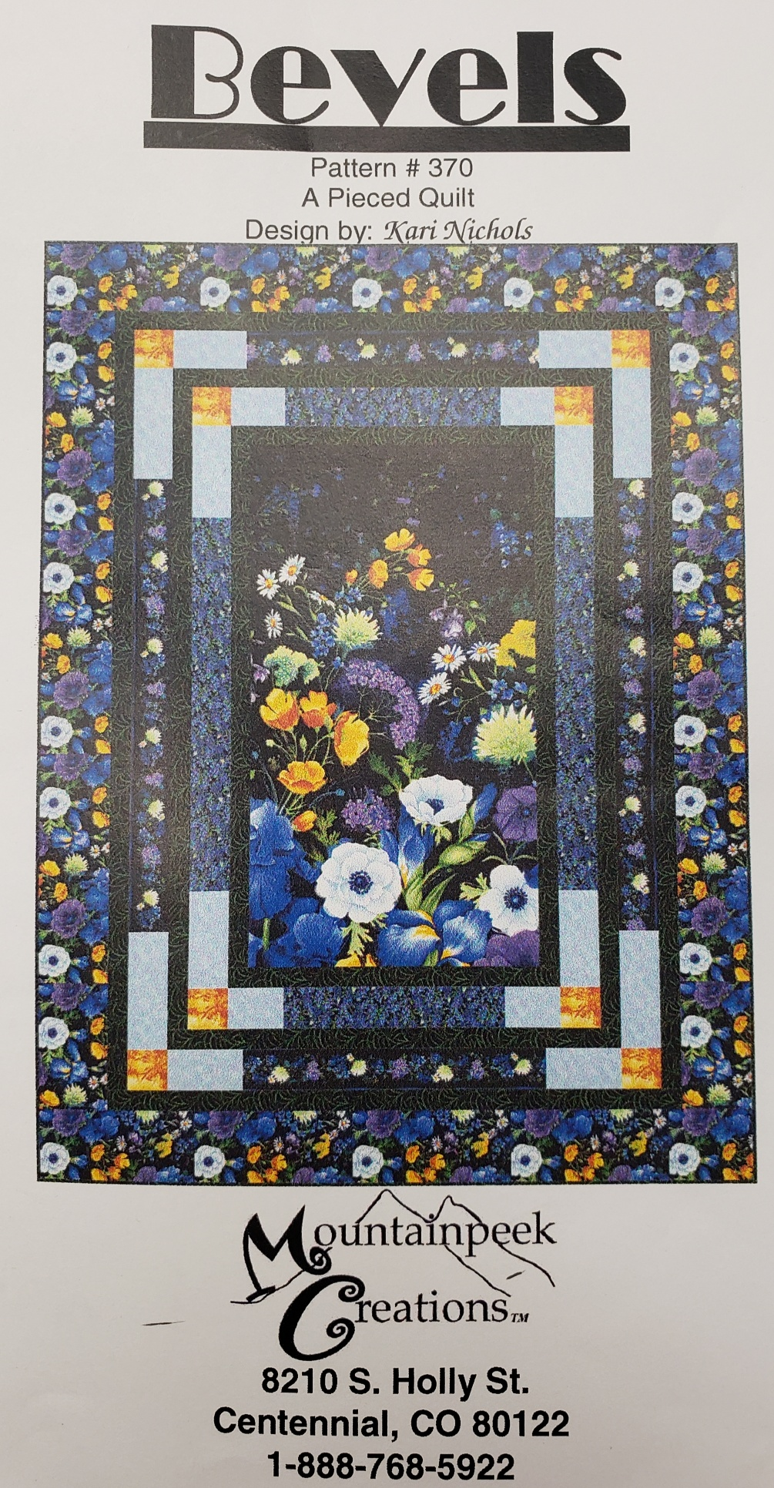
Raven Moon with Bevels Border
Class Info and Supply List

Quilt Size per Pattern: 53” x 71”
Shop Sample Pattern

Class Date and Time –

Tuesdays - January 14, 28 and February 11, 2020. Class time is 1:45 to 5:45 pm for each session.

Patterns: Raven Moon, Bevels

Fabrics per Bevels pattern. NOTE: if the outer border fabric is directional, purchase 2 1/2 yards of fabric rather than
2 1/4 yards as noted on pattern.

Standard sewing tools:  - cutting mat  - rotary cutter  - straight pins  - seam ripper  - pencil  - thread - I use Aurifil A1050-2600 light gray with nearly all my quilts  - Sewing machine with accessories and owner’s manual  - Ziploc bags to organize pieces  - Post it notes to label Ziploc bags | Rulers:  - 6 ½” x 24 ½” ruler  - 6 ½” x 12 ½” ruler

TOQS Class Rules and Requirements
- Reservations are required for all classes!
- Payment for the initial class is required at the time of reservation!
- Cancellation: If you have to cancel your participation in a class and are able to provide 24 hour notice you will receive a voucher for your class fee, good for use against a future class. If you cancel the day of class you will receive a voucher for 1/2 of the class fee, good for use against a future class. If you are a no show or cancel after the course has started, then no refund is available. There is no refund for classes taught by visiting teachers or for quilt retreats.
- Please note the classrooms of TOQS are "Fragrance Free" zones.
We have folks that are allergic, receiving medical treatment, are on oxygen or simply are just highly sensitive to scented soaps, lotions, perfumes and colognes. Therefore, for the sake of these quilters, please do not apply scented lotions, perfumes, body sprays or cologne prior to class.

