

4233 West Thunderbird Road, Phoenix, AZ 85053 602-843-1554

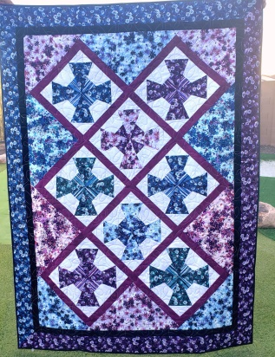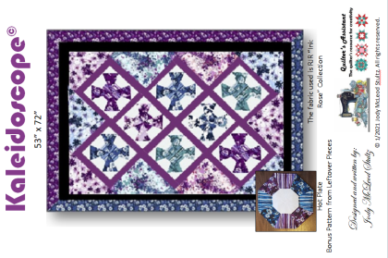

KALEIDOSCOPE
Class Info and Supply List

Approximately 53” X 72”

Actual Pattern
Shop Sample

Class Dates and times –

Tuesdays, July 13, 27, and August 13, 2021 – All sessions are from 1:45 pm to 5:45 pm.

Pattern: Kaleidoscope© by Quilter’s Assistant.

Fabrics per pattern. Pre-Class Work: please cut the strips as indicated in the pattern, label each strip and place them in their own baggies. If you are not comfortable doing the cutting, please wait until the first class.

Sewing Tools: Rulers:
- cutting mat | - 6 ½” x 24 ½” ruler
- rotary cutter | - 6 ½” x 12 ½” ruler
- straight pins | - 45° Kaleidoscope & Dresden Plate Ruler
- seam ripper
- pencil
- thread
- Sewing machine with accessories and owner’s manual
- Ziploc bags to organize pieces
- Post it notes to label Ziploc bags

TOQS Class Rules and Requirements
- Reservations are required for all classes!
- Payment for the initial class is required at the time of reservation!
- Cancellation: If you have to cancel your participation in a class and are able to provide 24 hour notice you will receive a voucher for your class fee, good for use against a future class. If you cancel the day of class you will receive a voucher for 1/2 of the class fee, good for use against a future class. If you are a no show or cancel after the course has started, then no refund is available. There is no refund for classes taught by visiting teachers or for quilt retreats.
- Please note the classrooms of TOQS are "Fragrance Free" zones.
We have folks that are allergic, receiving medical treatment, are on oxygen or simply are just highly sensitive to scented soaps, lotions, perfumes and colognes. Therefore, for the sake of these quilters, please do not apply scented lotions, perfumes, body sprays or cologne prior to class.
- Cell Phones: We ask that cell phones be silenced or on vibrate as to not disturb other students. If you need to talk a call, we understand and ask that you step out of the classroom while on the phone. Thank you!

