4233 West Thunderbird Road, Phoenix, AZ 85053 602-843-1554

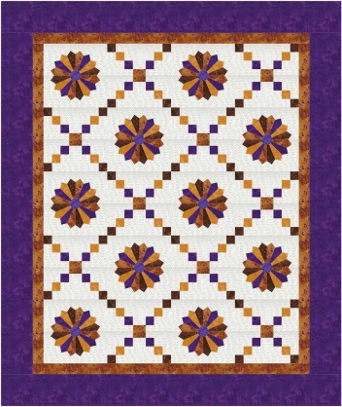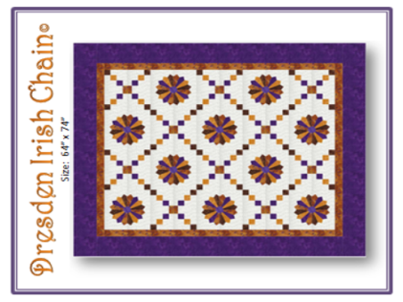

Dresden Irish Chain©
Class Info and Supply List

Quilt Size per Pattern: 64” x 74”

Shop Sample Pattern

Class Date and Time –

Wednesdays, October 20, November 3 and 17, 2021. Class time is 1:45 to 5:45 pm each session

Pattern: Dresden Irish Chain© designed by Jody McLeod Stultz, The Quilter’s Assistant

Pre-class work (if comfortable doing so): Cut the fabrics as shown on page 2 of the pattern. This will allow for class time to be spent sewing the project. Please label and put cut pieces into zip lock bags.

Fabrics per pattern.
Standard sewing tools:  - cutting mat  - rotary cutter  - straight pins  - seam ripper  - pencil  - thread - I use Aurifil A1050-2600 light gray with nearly all my quilts  - Sewing machine with accessories and owner’s manual  - Ziploc bags to organize pieces  - Post it notes to label Ziploc bags | Rulers:  - 18° Dresden Plate Ruler and Circle  - 8 ½” x 24 ½” ruler *  - 8 ½” x 12 ½” ruler *  * recommended, or, if you have a 12 1/2" square ruler, you might want to bring that to class, also.

TOQS Class Rules and Requirements
- Reservations are required for all classes!
- Payment for the initial class is required at the time of reservation!
- Cancellation: If you have to cancel your participation in a class and are able to provide 24 hour notice you will receive a voucher for your class fee, good for use against a future class. If you cancel the day of class you will receive a voucher for 1/2 of the class fee, good for use against a future class. If you are a no show or cancel after the course has started, then no refund is available. There is no refund for classes taught by visiting teachers or for quilt retreats.
- Please note the classrooms of TOQS are "Fragrance Free" zones.
We have folks that are allergic, receiving medical treatment, are on oxygen or simply are just highly sensitive to scented soaps, lotions, perfumes and colognes. Therefore, for the sake of these quilters, please do not apply scented lotions, perfumes, body sprays or cologne prior to class.
- Cell Phones: We ask that cell phones be silenced or on vibrate as to not disturb other students. If you need to take a call, we understand and ask that you step out of the classroom while on the phone. Thank you!

