Accent on Angles
Class Info and Supply List

Teacher: Mary Lou

4233 West Thunderbird Road, Phoenix, AZ 85053 602-843-1554

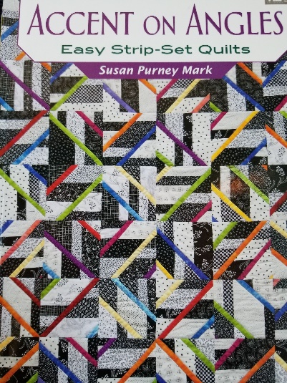

Dates –Weekday sessions: 9:15 A.M. on Wednesday

August 4, and August 18, 2021

Weekend sessions: 11:30 a.m. on Sunday

August 15, and August 29, 2021

Class Supply List
- Book: Accent on Angles by Susan Purney Mark
- Fabrics: As suggested on page 15 in book
- Thread: for piecing
- Rulers: 6 ½” x 24 ½” or 8 1/2” x 24 ½”
- OTHER TOOLS: sewing machine, scissors, rotary cutter and large mat, seam ripper, pins…etc.

Optional pre-class cutting: Cut as directed on page 16 except for the 6 strips 2 ¼” x 42” for binding. (I prefer my binding to be cut at 2 ½”).

Looking forward to seeing you in class.

TOQS Class Rules and Requirements
- Reservations are required for all classes!
- Payment for the initial class is required at the time of reservation!
- Cancellation: If you have to cancel your participation in a class and are able to provide 24 hour notice you will receive a voucher for your class fee, which is good for use against a future class. If you cancel the day of class you will receive a voucher for 1/2 of the class fee, which is good for use against a future class. If you are a no show or cancel after the course has started, then no refund is available. There is no refund for classes taught by visiting teachers or for quilt retreats.
- Please note the classrooms of TOQS are "Fragrance Free" zones.
We have folks that are allergic, receiving medical treatment, are on oxygen or simply are just highly sensitive to scented soaps, lotions, perfumes and colognes. Therefore, for the sake of these quilters, please do not apply scented lotions, perfumes, body sprays or cologne prior to class.

