

4233 West Thunderbird Road, Phoenix, AZ 85053 602-843-1554


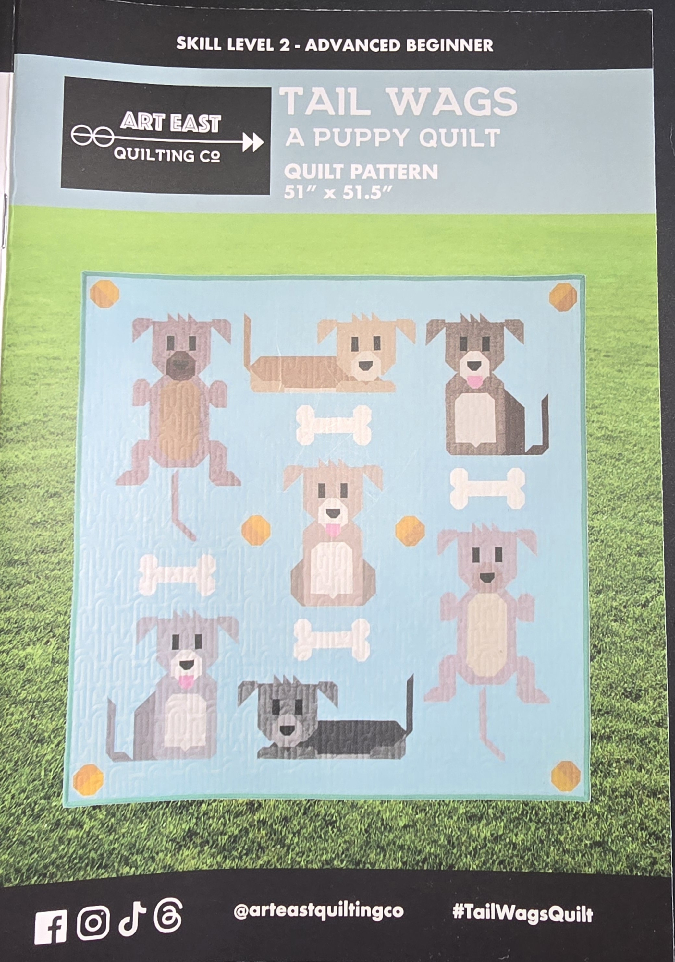

TAIL WAGS
A Puppy Quilt
Class Info and Supply List

Dates and time:
Thursday January 8, 2026 at 9:15 a.m.
Thursday January 22, 2026 at 9:15 a.m.
Thursday February 5, 2026 at 9:15 a.m.

Class Supply List
- Pattern: TAIL WAGS A Puppy Quilt from Art East Quilting Co.
- Fabrics: Suggestions are on back of the pattern.
- Thread: for piecing
- Rulers: 6 ½” x 24 ½” or 8 ½” x 24 ½”. Smaller rulers are also helpful.
- OTHER TOOLS: sewing machine, scissors, rotary cutter and large mat, seam ripper, pins…etc. (Note: The Acorn Precision Piecing products Easy Press and Glue are very helpful in quilt.)

Optional pre-class cutting instructions:
- If you want to get a head start on the cutting, we are starting with the Front Facing Puppy. The cutting guide for this block is on page 9.

TOQS Class Rules and Requirements
- Registration is required for all classes! The deadline for registration is 24 hours prior to the start of class.
- Attendance at the first class is required. If you cannot make this class, please discuss it with Sherri.
- If there are less than two sign-ups, the class may be rescheduled.
- Cancellation: If you need to cancel your participation in a class and can provide 24-hour notice you will receive a voucher for your class fee, good for use against a future class. If you cancel the day of class, you will receive a voucher for 1/2 of the class fee, good for use against a future class. If you are a no show or cancel after the course has started, then no refund is available. There is no refund for classes taught by visiting teachers or for quilt retreats.
- Please note the classrooms of TOQS are "Fragrance Free" zones. We have folks that are allergic, receiving medical treatment, are on oxygen or simply are just highly sensitive to scented soaps, lotions, perfumes, or colognes. Therefore, for the sake of these quilters, please do not apply scented lotions, perfumes, body sprays or cologne prior to class.
- Cell Phones: We ask that cell phones be silenced or on vibrate to not disturb other students. If you need to take a call, we understand and ask that you step out of the classroom while on the phone. Thank you!

