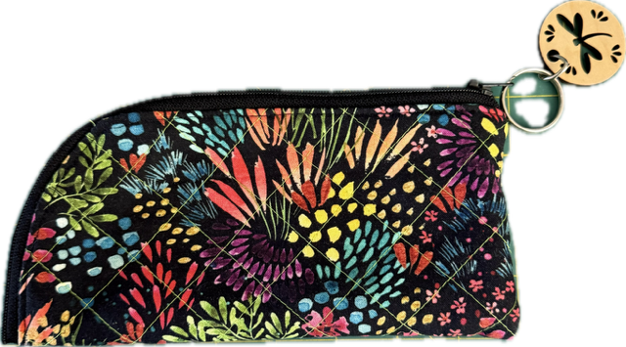
Featherweight Club Meeting on September 24th
Our Vintage 221 Friends Featherweight Club will meet on Wednesday, Sept. 24. Our project will be the Racoon Case- a free pattern from Pink Pony Design. Pattern copies will be provided. It is a quilted zipper case that is perfect for rotary cutters, sewing supplies or sunglasses. The required supplies are:

- A 9” square of fabric for the exterior of the pouch
- A 9” square of fabric for the interior
- A 9” square of fusible fleece or batting
- A 25” or longer zipper. (Note: you will be using one side of the zipper- the other side can be saved for another project).

You will also need standard sewing supplies such as:
- Scissors and rotary cutter
- Cutting map
- Marking pens or chalk
- Pins or clips
- Thread and bobbin

