

4233 West Thunderbird Road, Phoenix, AZ 85053 602-843
CURVY LOG CABIN – Supply List

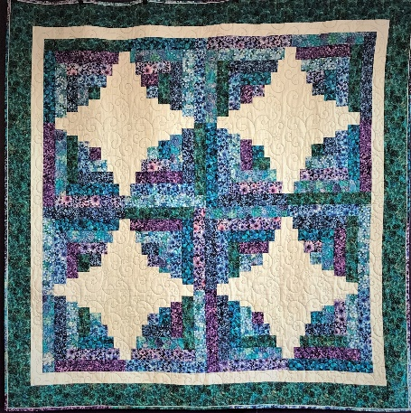

Instructor: Julia
Dates: Saturday January 21st and February 11th, 2023
Time: 1:45 PM – 5:45 PM
Fee: $30 per session

What you need:
FABRIC:
(32) 2 ½ “strips OR (8) 1/3 yard cuts
2 yards of white or light
1 yard for outer border
4 1/8 yards for backing

PLEASE CUT (32) color 2 ½ strips and (25) white or light 1 ½” strips PRIOR TO CLASS.

- Cutting mat
- Rotary Cutter
- Ruler 6 ½ x 12 ½ or longer
- Thread for piecing
- Sewing Kit: Pins, seam ripper, marking tools, ¼ inch foot, extra bobbins and needles
- Sewing Machine and owner’s manual

TOQS Class Rules and Requirements
- Reservations are required for all classes!
- Payment for the initial class is required at the time of reservation!
- Cancellation: If you have to cancel your participation in a class and are able to provide 24 hours notice you will receive a voucher for your class fee, good for use against a future class. If you cancel the day of class, you will receive a voucher for 1/2 of the class fee, good for use against a future class. If you are a no show or cancel after the course has started, then no refund is available. There is no refund for classes taught by visiting teachers or for quilt retreats.
- Please note the classrooms of TOQS are "Fragrance Free" zones.
We have folks that are allergic, receiving medical treatment, are on oxygen or simply are just highly sensitive to scented soaps, lotions, perfumes and colognes. Therefore, for the sake of these quilters, please do not apply scented lotions, perfumes, body sprays or cologne prior to class.
- Cell Phones: We ask that cell phones be silenced or on vibrate as to not disturb other students. If you need to talk a call, we understand and ask that you step out of the classroom while on the phone. Thank you!

