4233 West Thunderbird Road,

Phoenix, AZ 85053 602-843-1554

Cubbie Cube
Free Pattern by
Sallie Tomato

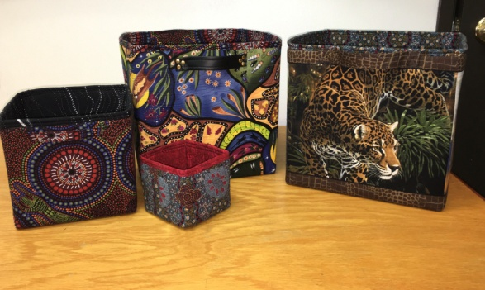

Shop Sample

Class Dates and Times:

Sunday
- March 20, 2022 11:15 am to 3:15 pm
- May 15, 2022 11:15 am to 3:15 pm
Pattern Free download-Simple storage cubes
sallietomato.com/collections/patterns-1/products/simple-storage-cubes-instant-download

Fabrics in sample:
3 sizes:
- Small (4” SQ.)
- Medium (7” SQ.)
- Large (10 ½” SQ.)

Fabric Requirements and Pre-Class Cutting:
EXTERIOR (42” wide)
- Small - 1/4 yard – Cut (1) 9”x 12”
- Medium – 1/2 yard – Cut (1) 15”x 21” (5”sq. focal point if using a panel with 4 pictures)
- Large – 2/3 yard – Cut (1) 22” x31 ½ “ (8” sq. focal point if using a panel with 4 pictures)
LINING (42” wide)
- Small - 1/2 yard – Cut (1) 9”x 14”
- Medium -2/3 yard – Cut (1) 15”x 23”
- Large -1 yard – Cut (1) 22” x 33 ½ “ **(1 ½ yard if doing panel version)

FOAM (58” wide) Fusible on 1 side only or SEW-IN FOAM
- Small - 1/4 yard – Cut (1) 9”x 12”
- Medium – 1/2 yard – Cut (1) 15”x 21”
- Large – 2/3 yard – Cut (1) 22” x31 ½ “
PELTEX (20” wide) Fusible on both sides works best
- Small – not needed to small
- Medium – 1/2 yard – Cut (6) 6 1/4" SQS.
- Large – 7/8 yard – Cut (6) 10 1/4” SQS.

Supplies

Standard sewing tools:  - Threads to match  - cutting mat  - rotary cutter –45mm  - ¼” steam-a-seam fusible tape  - straight pins  - seam ripper  - Chalk marker  - Frixion pen  - Wonder clips  - Sewing machine with accessories and owner’s manual | Rulers:  - 6 ½” x 24 ½”

TOQS Class Rules and Requirements
- Reservations are required for all classes!
- Payment for the initial class is required at the time of reservation!
- Cancellation: If you have to cancel your participation in a class and are able to provide 24 hour notice you will receive a voucher for your class fee, good for use against a future class. If you cancel the day of class you will receive a voucher for 1/2 of the class fee, good for use against a future class. If you are a no show or cancel after the course has started, then no refund is available. There is no refund for classes taught by visiting teachers or for quilt retreats.
- Please note the classrooms of TOQS are "Fragrance Free" zones.
We have folks that are allergic, receiving medical treatment, are on oxygen or simply are just highly sensitive to scented soaps, lotions, perfumes and colognes. Therefore, for the sake of these quilters, please do not apply scented lotions, perfumes, body sprays or cologne prior to class.
- Cell Phones: We ask that cell phones be silenced or on vibrate as to not disturb other students. If you need to talk a call, we understand and ask that you step out of the classroom while on the phone. Thank you!

