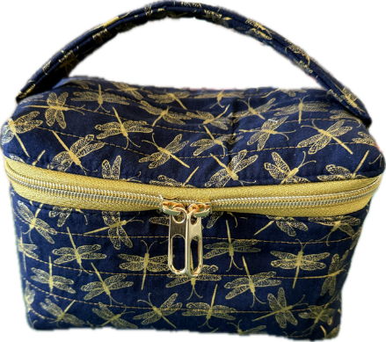
Cosmetic Bag Project for Oct. 22
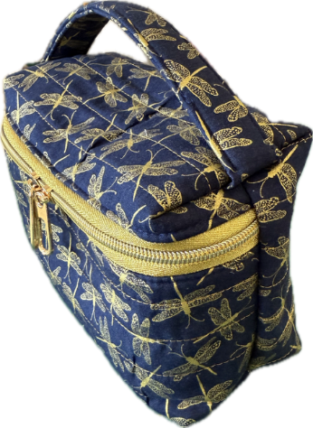
Our project for the upcoming Featherweight Club meeting on Oct. 22 will be a boxy shaped bag that can be used for cosmetics, sewing supplies, or anything else that you want to put in it! The finished bag measures about 9” high by 3 ½” deep. It features a padded handle on top and double zipper pulls.
Supply list:
- Fabric for the outer bag and strap (roughly 12 5/8” x 22 ½”)
- Fabric for the bag lining and binding (roughly 12” x 20”)
- Fusible fleece (roughly 12 5/8” x 22 ½”)
- Zipper- at least 13 ¾” with 2 zipper pulls (zipper by the yard works great for this)
General sewing supplies:
- Pins or clips
- Marking pens
- Cutting supplies (ruler, rotary cutter, scissors)
- Thread and bobbins (hint: make sure you bring thread to match both the outer bag fabric and inner bag fabric)

