

4233 West Thunderbird Road, Phoenix, AZ 85053 602-843-1554

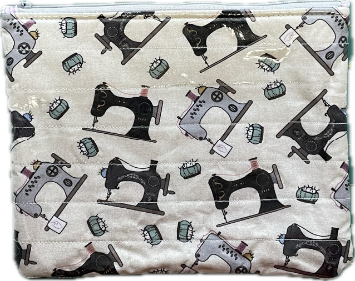
Vinyl Covered Zipper Pouches

Class Info and Supply List

Class Dates and times –

Friday, January 26 or Saturday, March 16 – All sessions are from 9:15 AM – 1:15 PM
Directions will be provided at the class session.

Fabric Requirements:
- ¼ yd fabric for outer pouch or 1 empty candy bag (at least 8 ½”x 4 ½”)
- ¼ yd fabric for inner lining
- 2 batting pieces large enough for front and back of pouch (8” x 10” should be large enough)
- Zipper (8” or longer)

Sewing Tools: Rulers:
- Cutting mat | - 8 ½” x 24 ½” or smaller ruler or
- Rotary cutter  - Scissors | - 9” square ruler
- Straight pins or clips
- Seam ripper
- Pencil or marking tool
- Thread
- Walking foot
- Vinyl sewing machine needles

TOQS Class Rules and Requirements
- Reservations are required for all classes!
- Payment for the initial class is required at the time of reservation!
- Cancellation: If you have to cancel your participation in a class and are able to provide 24 hour notice you will receive a voucher for your class fee, good for use against a future class. If you cancel the day of class you will receive a voucher for 1/2 of the class fee, good for use against a future class. If you are a no show or cancel after the course has started, then no refund is available. There is no refund for classes taught by visiting teachers or for quilt retreats.
- Please note the classrooms of TOQS are "Fragrance Free" zones.
We have folks that are allergic, receiving medical treatment, are on oxygen or simply are just highly sensitive to scented soaps, lotions, perfumes and colognes. Therefore, for the sake of these quilters, please do not apply scented lotions, perfumes, body sprays or cologne prior to class.
- Cell Phones: We ask that cell phones be silenced or on vibrate as to not disturb other students. If you need to talk a call, we understand and ask that you step out of the classroom while on the phone. Thank you!

