

4233 West Thunderbird Road, Phoenix, AZ 85053 602-843-1554

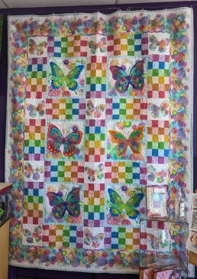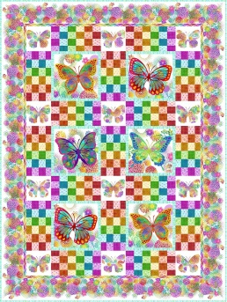
Unusual Garden II
Butterfly Quilt

Approximately 82” X 109”
Class Info and Supply List
Shop Sample
Actual Pattern

Class Dates and times –

Fridays, April 29, May 13 and 27, 2022 – All sessions are from 1:45 pm to 5:45 pm.

Pattern: Unusual Garden II Butterfly Quilt© by Jason Yenter

Fabrics per pattern.
Pre-Class Work: If you are not comfortable doing the cutting or tracing, please wait until the first class.
- Please cut the pieces as indicated in the pattern, label the pieces and place them in their own baggies. Do not cut the panel – we will do it in class.
- Trace the butterfly template onto Steam-a-Seam or Heat N Bond sheets. You need to trace the template 12 times.

Sewing Tools: Rulers:
- Cutting mat | - 6 ½” x 24 ½” OR 8 ½” x 24 ½” ruler
- Rotary cutter | - 6 ½” x 12 ½” OR 8 ½” x 12 ½” ruler
- Straight pins | - 16 ½” square ruler – optional – needed to square up the butterfly panels
- Seam ripper  - Pencil  - Thread  - Sewing machine with accessories and owner’s manual  - Extra sewing machine needles in case of breakage  - Ziploc bags to organize pieces  - Post it notes to label Ziploc bags | Recommended additional tool:  - Light box for tracing butterflies

TOQS Class Rules and Requirements
- Reservations are required for all classes!
- Payment for the initial class is required at the time of reservation!
- Cancellation: If you have to cancel your participation in a class and are able to provide 24 hour notice you will receive a voucher for your class fee, good for use against a future class. If you cancel the day of class you will receive a voucher for 1/2 of the class fee, good for use against a future class. If you are a no show or cancel after the course has started, then no refund is available. There is no refund for classes taught by visiting teachers or for quilt retreats.
- Please note the classrooms of TOQS are "Fragrance Free" zones.
We have folks that are allergic, receiving medical treatment, are on oxygen or simply are just highly sensitive to scented soaps, lotions, perfumes and colognes. Therefore, for the sake of these quilters, please do not apply scented lotions, perfumes, body sprays or cologne prior to class.
- Cell Phones: We ask that cell phones be silenced or on vibrate as to not disturb other students. If you need to talk a call, we understand and ask that you step out of the classroom while on the phone. Thank you!

