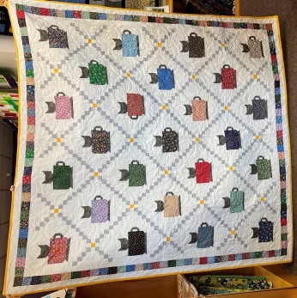

Tea Cats

Class Info and Supply List

4233 West Thunderbird Road, Phoenix, AZ 85053 602-843-1554

Class Date and Time –

Monday October 3, 17, and 31, 2022, from 1:45 pm to 5:45 pm

Required Pattern: Tea Cats

Fabric and supplies need for class
- 1 Layer Cake
- 5-3/4 yards background fabric
- 5/8 yard fabric A (cat heads)
- 7/8 yard fabric B (Irish Chain Grey
- 1 yard fabric for center of Irish Chain and binding
- 82 x 82” backing

Standard sewing tools:  - cutting mat  - rotary cutter2  - straight pins  - seam ripper  - pencil  - thread - I use Aurifil A1050-2600 light gray with nearly all my quilts  - Sewing machine with accessories and owner’s manual  - Post it notes to label fabrics  - Acorn Precision Piecing Products – Seam Align Gentle Hold Fabric Glue | Rulers:  - 6-1/2 x 24” or larger  - 10-1/2” Square or larger  - 6-1/2 x 12” ruler or larger

TOQS Class Rules and Requirements
- Reservations are required for all classes!
- Payment for the initial class is required at the time of reservation!
- Cancellation: If you have to cancel your participation in a class and are able to provide 24 hour notice you will receive a voucher for your class fee, good for use against a future class. If you cancel the day of class you will receive a voucher for 1/2 of the class fee, good for use against a future class. If you are a no show or cancel after the course has started, then no refund is available. There is no refund for classes taught by visiting teachers or for quilt retreats.
- Please note the classrooms of TOQS are "Fragrance Free" zones.
We have folks that are allergic, receiving medical treatment, are on oxygen or simply are just highly sensitive to scented soaps, lotions, perfumes and colognes. Therefore, for the sake of these quilters, please do not apply scented lotions, perfumes, body sprays or cologne prior to class.
- Cell Phones: We ask that cell phones be silenced or on vibrate as to not disturb other students. If you need to talk a call, we understand and ask that you step out of the classroom while on the phone. Thank you!

