4233 West Thunderbird Road, Phoenix, AZ 85053 602-843-1554

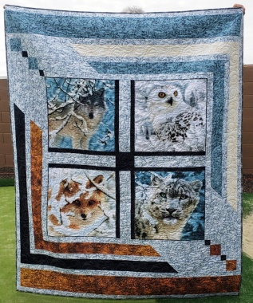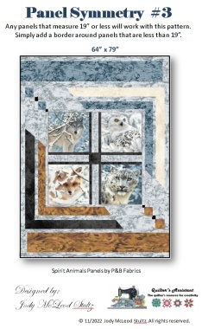

Panel Symmetry #3 with

Spirit Animals
Class Info and Supply List

Quilt Size per Pattern: 64” x 79”
Shop Sample Pattern

Class Dates and Times –
- Fridays, April 14, April 28, and May 12, 2023. Each session is from 1:45 to 5:45 pm.

Pattern: Panel Symmetry #3 with Spirit Animals by The Quilter’s Assistant

Fabrics: per the pattern
If you prefer, cut the fabrics as directed in the pattern before the first class. Do not cut the panel until the instructor guides you in the first class.
Standard sewing tools:  - cutting mat  - rotary cutter and replacement blades  - straight pins  - seam ripper  - pencil  - thread - I use Aurifil A1050-2600 light gray with nearly all my quilts  - Sewing machine with accessories and owner’s manual  - Ziploc bags  - Post it notes | Rulers:  - 6 ½” x 12 ½” ruler or 8 ½” x 12 ½”  - 6 ½” x 24 ½” ruler or 8 ½” x 24 ½”  - 20 1/2" square ruler*  * Optional but recommended in order to square up the panel pictures more efficiently.

TOQS Class Rules and Requirements
- Reservations are required for all classes!
- Payment for the initial class is required at the time of reservation!
- Cancellation: If you have to cancel your participation in a class and are able to provide 24 hour notice you will receive a voucher for your class fee, good for use against a future class. If you cancel the day of class you will receive a voucher for 1/2 of the class fee, good for use against a future class. If you are a no show or cancel after the course has started, then no refund is available. There is no refund for classes taught by visiting teachers or for quilt retreats.
- Please note the classrooms of TOQS are "Fragrance Free" zones.
We have folks that are allergic, receiving medical treatment, are on oxygen or simply are just highly sensitive to scented soaps, lotions, perfumes and colognes. Therefore, for the sake of these quilters, please do not apply scented lotions, perfumes, body sprays or cologne prior to class.
- Cell Phones: We ask that cell phones be silenced or on vibrate as to not disturb other students. If you need to talk a call, we understand and ask that you step out of the classroom while on the phone. Thank you!

