4233 West Thunderbird Road, Phoenix, AZ 85053 602-843-1554

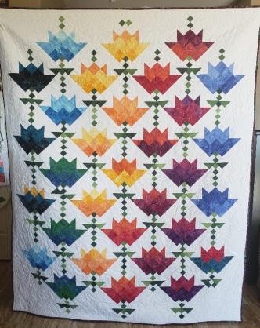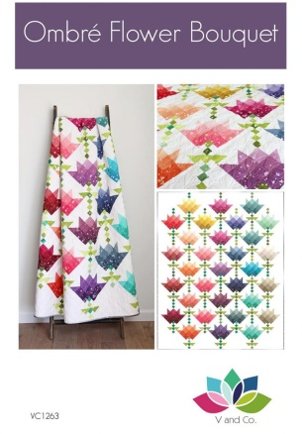

OMBRE FLOWER BOUQUET
Class Info and Supply List

Lap Size - 56” X 70”
Baby Quilt – 56” x 56”

Teacher: Jody

Actual Pattern
Shop Sample

Class Dates and times –

Fridays, February 4, 18, and March 4, 2022 – All sessions are from 9:15 am to 1:15 pm

Pattern: Ombre Flower Bouquet by V and Co.

Fabrics per pattern. PLEASE READ: The pattern calls for an ombre jelly roll. In lieu of a jelly roll, the quilt sample is made from ombre fabrics, cut into 2 ½” x WOF strips. Forty (40) 2 ½” x WOF strips are needed from various ombres. You may use an ombre fabric for several flowers if you wish. Therefore, purchase enough fabrics to enable you to cut the 40 strips. For example, if you have chosen five (5) different ombre fabrics, you will need eight (8) 2 ½” x WOF strips from each. In this example, you will purchase 2/3 yard of each ombre fabric.

Sewing Tools: Rulers:
- cutting mat | - 6 ½” x 24 ½” ruler OR 8 ½” x 24 ½” ruler
- rotary cutter | - 6 ½” x 12 ½” ruler OR 8 ½” x 12 ½” ruler
- straight pins | - 10 1/2” square ruler or larger
- seam ripper
- pencil
- thread - I use Aurifil A1050-2600 light gray with nearly all my quilts
- Sewing machine with accessories and owner’s manual
- Ziploc bags to organize pieces
- Post it notes to label Ziploc bags

TOQS Class Rules and Requirements
- Reservations are required for all classes!
- Payment for the initial class is required at the time of reservation!
- Cancellation: If you have to cancel your participation in a class and are able to provide 24 hour notice you will receive a voucher for your class fee, good for use against a future class. If you cancel the day of class you will receive a voucher for 1/2 of the class fee, good for use against a future class. If you are a no show or cancel after the course has started, then no refund is available. There is no refund for classes taught by visiting teachers or for quilt retreats.
- Please note the classrooms of TOQS are "Fragrance Free" zones.
We have folks that are allergic, receiving medical treatment, are on oxygen or simply are just highly sensitive to scented soaps, lotions, perfumes and colognes. Therefore, for the sake of these quilters, please do not apply scented lotions, perfumes, body sprays or cologne prior to class.
- Cell Phones: We ask that cell phones be silenced or on vibrate as to not disturb other students. If you need to talk a call, we understand and ask that you step out of the classroom while on the phone. Thank you!

