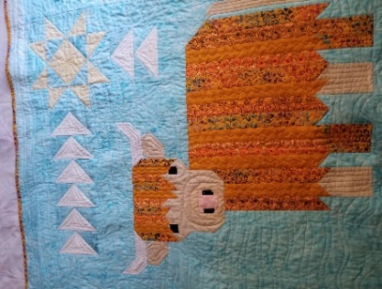
CATTLE CALL
A Highland Coo Quilt
Class Info and Supply List

Teacher: Mary Lou

4233 West Thunderbird Road, Phoenix, AZ 85053 602-843-1554

Dates –

Saturdays, July 30 and Saturday August 13, 2022

Time –

9:15 a.m. to 1:15 pm

Class Supply List
- Pattern: Cattle Call A Highland Coo Quilt by Art East Quilting Co.
- Fabrics: As suggested on pattern.
- Thread: for piecing
- Rulers: 6 ½” x 24 ½” or 8 ½ ” x 24 ½”, Wing Clipper ruler by Creative Grid
- OTHER TOOLS: sewing machine, scissors, rotary cutter and large mat, seam ripper, pins…etc.

Optional pre-class cutting instructions: –
Cut per instructions on page 2 except for the Flying Geese. We will be using the Wing Clipper ruler. Be sure to label all your pieces.

TOQS Class Rules and Requirements
- Reservations are required for all classes!
- Payment for the initial class is required at the time of reservation!
- Cancellation: If you have to cancel your participation in a class and are able to provide 24 hour notice you will receive a voucher for your class fee, which is good for use against a future class. If you cancel the day of class you will receive a voucher for 1/2 of the class fee, which is good for use against a future class. If you are a no show or cancel after the course has started, then no refund is available. There is no refund for classes taught by visiting teachers or for quilt retreats.
- Please note the classrooms of TOQS are "Fragrance Free" zones.
We have folks that are allergic, receiving medical treatment, are on oxygen or simply are just highly sensitive to scented soaps, lotions, perfumes and colognes. Therefore, for the sake of these quilters, please do not apply scented lotions, perfumes, body sprays or cologne prior to class.

