

4233 West Thunderbird Road, Phoenix, AZ 85053 602-843-1554

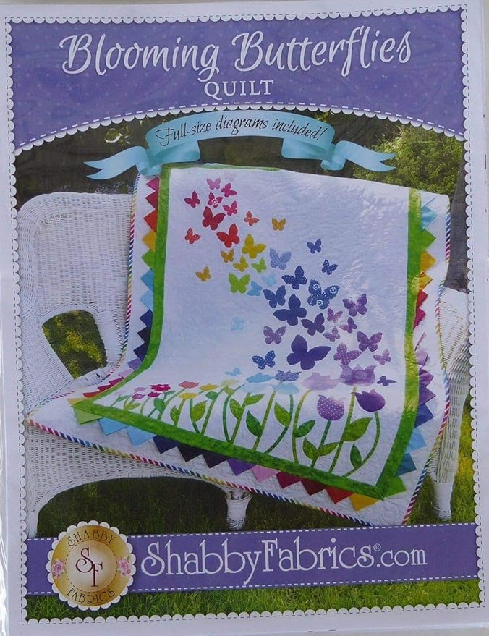

Blooming Butterflies
Class Info and Supply List

Dates and times:
Thursdays at 9:15 a.m. – 1:15 p.m.
February 12, February 26, and March 5, 2026

Class Supply List
- Pattern: Blooming Butterflies Quilt pattern from Shabby Fabrics.
- Fabrics: As suggested in pattern. .
- Fusible web such as Wonder Under, 2 yard
- Thread: for piecing and applique
- Rulers: 6 ½” x 24 ½” or 8 ½” x 24 ½”.

- OTHER TOOLS: sewing machine, scissors, rotary cutter and large mat, seam ripper, pins…etc.
- Optional helpful tools: applique pressing sheet or parchment paper, lightbox for tracing applique pieces, fine permanent marker for tracing.

Optional instructions:
If you are comfortable with the applique process, start tracing the leaves and stems of the tulips on the fusible web...Please make note that only leaves #19, #22, #23, #24, #28, #29 and #33 need to be copied in reverse.

TOQS Class Rules and Requirements
- Registration is required for all classes! The deadline for registration is 24 hours prior to the start of class.
- Attendance at the first class is required. If you cannot make this class, please discuss it with Sherri.
- If there are less than two sign-ups, the class may be rescheduled.
- Cancellation: If you need to cancel your participation in a class and can provide 24-hour notice you will receive a voucher for your class fee, good for use against a future class. If you cancel the day of class, you will receive a voucher for 1/2 of the class fee, good for use against a future class. If you are a no show or cancel after the course has started, then no refund is available. There is no refund for classes taught by visiting teachers or for quilt retreats.

