Class Information & Pre-Class Handout
Instructor: Jackie Dunckley, Porch & Pattern LLC
Course Format: Three 2-hour classes
Skill Level: Confident Beginner and Up
Pattern: Ombre Puff Quilt by Lo & Behold Stitchery

Course Description
Create an irresistibly cozy quilt with beautiful texture and color! In this class you'll learn how to construct dimensional puff blocks, organize fabrics for a beautiful ombre transition, assemble rows efficiently, and finish a quilt that is as comfortable as it is eye-catching. The class is paced over three two-hour sessions to give you time to sew between meetings while receiving guidance at each stage.

Session Breakdown

Session 1: Fabric Selection & Puff Construction
• Review pattern and supplies
• Fabric selection and ombre planning
• Cutting and constructing puff blocks
Supplies needed: Basic sewing supplies, sewing machine with neutral thread, needles (90/14 recommended), and fabrics
Homework: Complete all puff blocks before Session 2.

Session 2: Layout & Quilt Assembly
• Organize puffs into an ombre layout
• Sew puffs into rows
Supplies needed: supplies from class one, completed puffs, labeling supplies (I use rubber bands and mini post it notes; large magic clips might be used)
Homework: Complete row assembly as discussed in class.

Session 3: Finishing Your Quilt
• Attach rows while stuffing along the way
• Complete quilt top assembly
• Discuss quilting options, binding, and quilt care
• Troubleshooting and finishing tips
Supplies needed: All prior supplies, Fiber Fill, magic clips can be very helpful. For completing the quilt, you will need batting (optional), quilting thread (will discuss in class), and binding (discussed in class)

Pre-Class Preparation
• Read through this pre-class pattern handout and choose your quilt size.
• Gather fabrics and fiber fill according to the pattern requirements.
• Bring your sewing machine in good working order with a new needle and neutral thread.
• No fabric cutting is required before the first class

Bring to Class
• Fabric and fiber fill* (Fiber fill is used in the 3rd class)
• Sewing machine and power cord
• Rotary cutter, mat, and rulers
• Basic sewing supplies (pins/clips, seam ripper, scissors)
• Neutral piecing thread

Fabric selection guidance (chart below)
In most of my puff quilts, I use between 20-40 different fabric solids and prints. As general guidelines:
- 2 sets of fabrics are used
  - the “pretty colors” – these are the fabrics you pick for the top of your quilt
  - Puff backing – you will NOT see this on your quilt – so use up scraps or even use quilter’s quality muslin. [this is referred to as the “scrap” in the chart above]
- Select a large scale fabric that has the two colors you want to use as your ends of the Ombre (for the top of the quilt). In the photo quilt – I wanted to use oranges and forest greens
- Build color selections in different tones and saturations of those two color ways. They need to go from dark to very faint to white in order to create the transition
- I would suggest buying only a fat quarter or 1/3 yd of any one fabric. The variation is key. Too much of one print will not create the ombre
- It’s ok to have only 3 or 4 puffs of one fabric. This is a time for you to dig into your stash and scrap basket. I’ve used llamas, kitties, forest creatures, whimsy even in the most subtle quilt. The photo quilt contains many of these – but in the right shades to all blend
- In the middle of the ombre quilt – you will need to have low volume light fabrics to transition. Do not only pick one white – but add low volume prints with the same colors from your large scale fabric print to create the transition.

Fabric Requirements
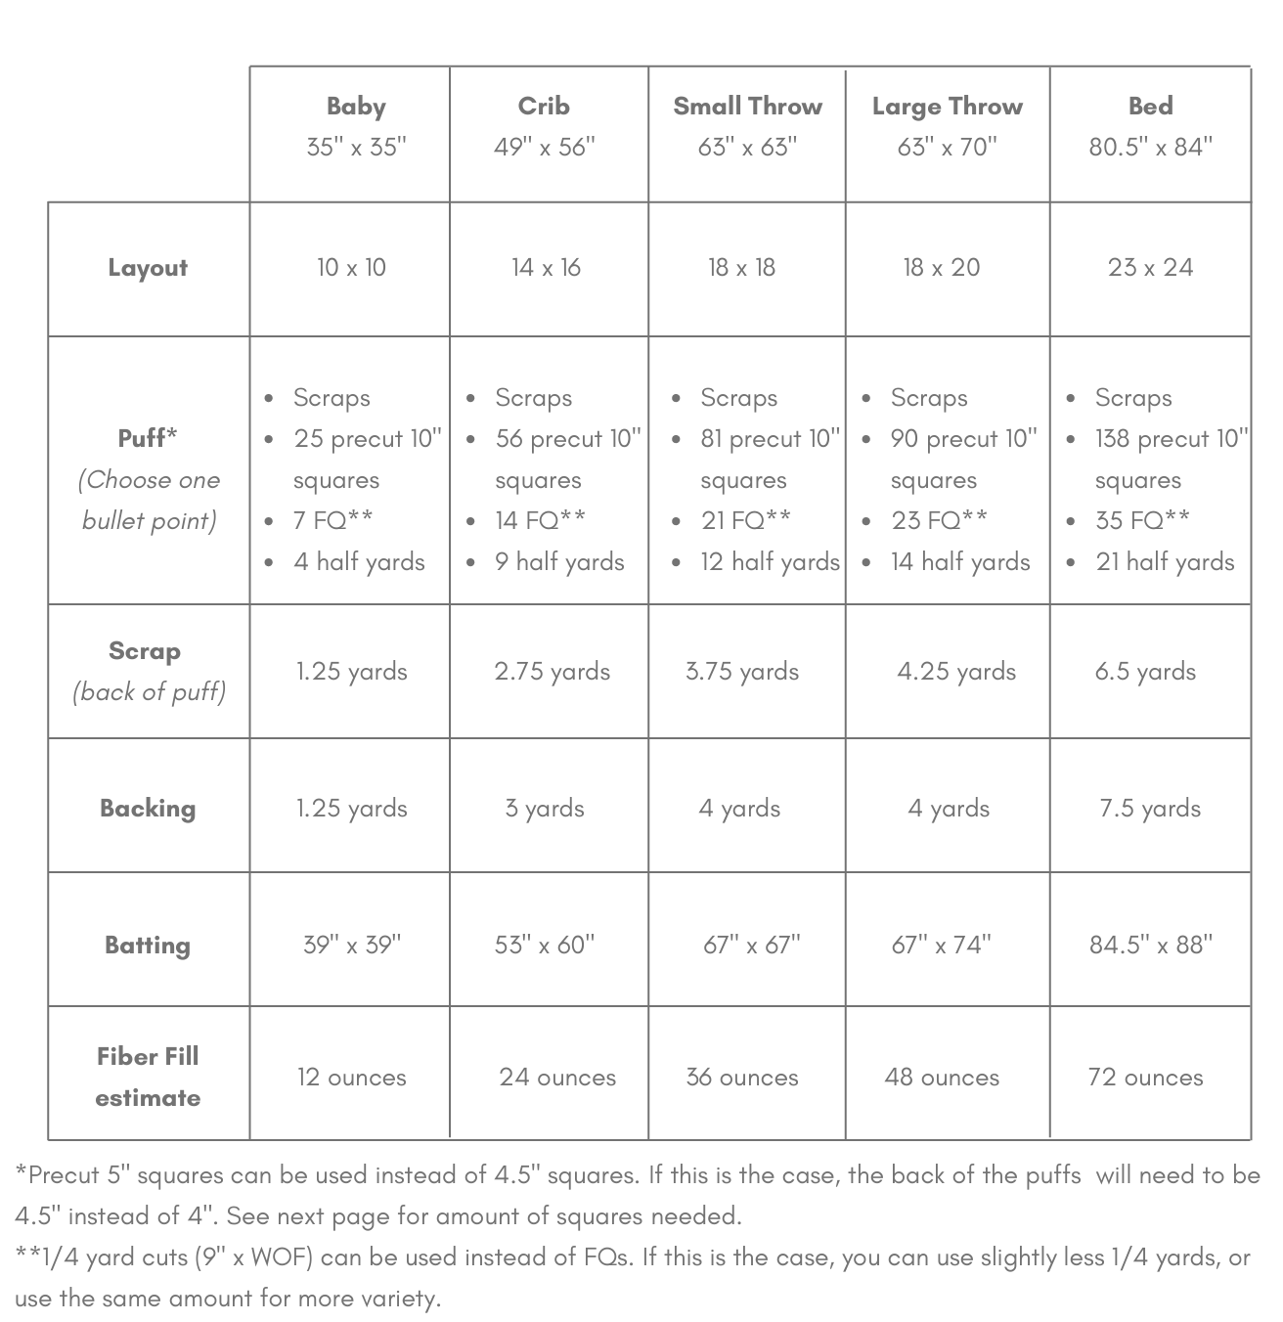
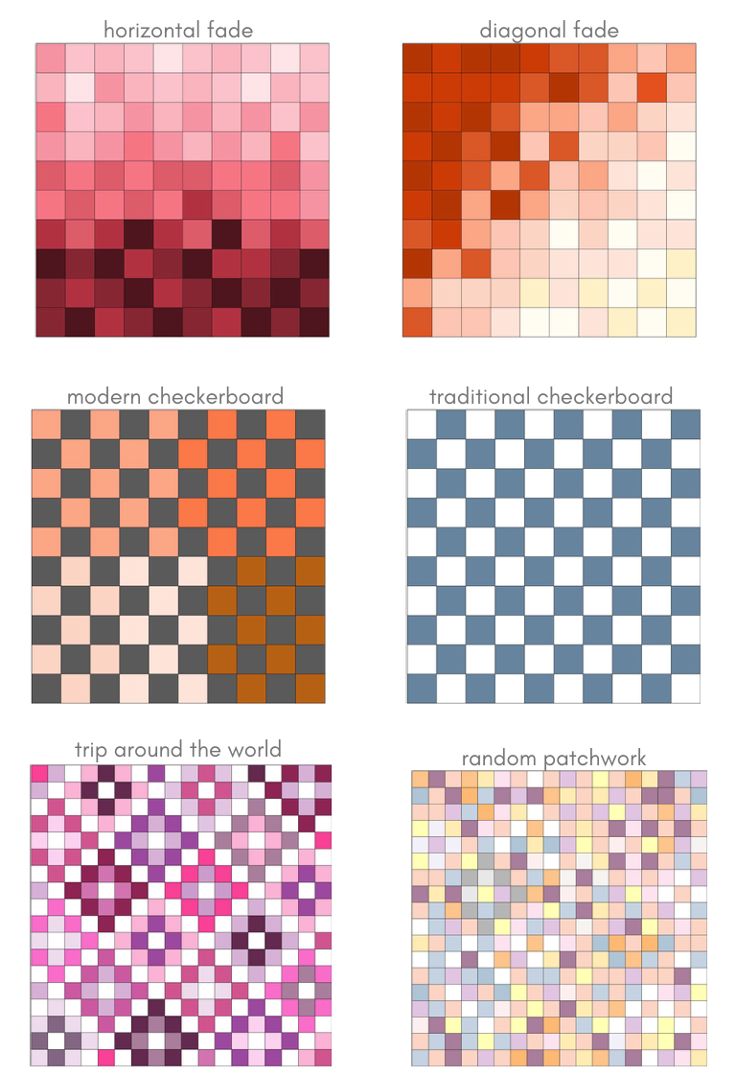
Here are just a few samples of possible layouts. We will discuss more in the first class

Ombre Puff Quilt is used with permission from Lo & Behold Stitchery. Copyright 2020. All rights reserved.

