4th of July or Painters Palette
Carol Hattan
cahattan@gmail.com
360 607 3473
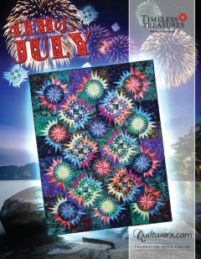
http://www.quiltworx.com/instructors/carol-hattan/
4th of July: a remake of old pattern - This pattern is comprised with (5) basic blocks Groups design with our newest Quiltworx Mixer Group called Fireworks.
Painters Palette: The (5) block elements used in this Quilt Layout were design as part of a new Mixer Group called Fireworks but is written to be used with two Quiltworx strip sets (48 strips per set)
Basic supplies:
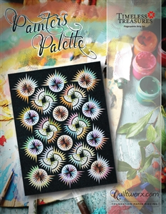
Supplies:
Sewing Machine, power cord, foot peddle, ¼ - inch foot or ability to adjust to a 1/4inch, new needle (recommend size 70 microtex (sharp) or 80 microtex (sharp).
Thread to blend with our fabrics

Rotary cutter (middle or large size), small mat, and ruler.
Seam ripper
Flower Head pins
Scissors small
Glue stick (water soluble – fabric to paper) and glue pen (fabric to fabric) and Restickable glue stick (scotch brand at office depot - I will have some of these since they are hard to find)
Scotch tape to fix paper goofs
Gallon (4) plastic bags and paper clips (better than clips as they stack)
If you have a Purple "Thang" or stiletto bring it along.

Add a quarter 6 or12. If you are buying one a 12 is a good place to start. There are two types available. One has a tapered edge and one is straight and thick. The straight is the better choice. You also need a folding temple when you work. I will have some of these.

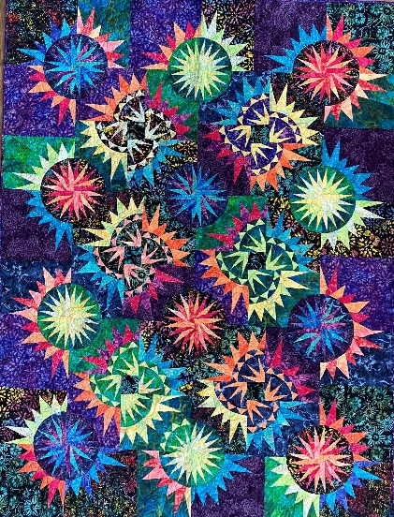
My quilt was made with the 4th of July pattern but could be make with your scraps. If you are using scraps I would buy the 4th of July pattern as the other pattern focuses on 2 ½ strips.

