Instructions for Making a Mask with Elastic

Cut elastic into 6 inch pieces.

Insert a piece of elastic in between the two fabric pieces like this: | 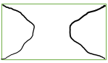
Stitch around all sides using a ½” seam allowance. Leave a 3” opening in one of the long sides. | 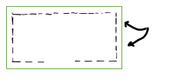  (Elastic is inside the 2 layers as noted above)
Clip all four of the corners- Do not clip through the seams
Turn right side out – poke out the corners – press

Top Stitch ¼” all the way around
Create two pleats/tucks in each side to make each side 3 ¼” in length

Stitch along each side to secure pleats | 