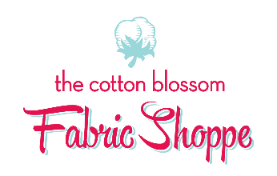

Embroidery Basics
Price: free if you bought your machine from us but must call and reserve a spot

Instructor: Robin Thomas

Skill Level: Beginner
Prerequisite: must know basic functions of machine. Please attend at least one training session on your machine before this class.
THIS CLASS IS FREE FOR OWNERS THAT HAVE PURCHASED NEW BABY LOCK MACHINES FROM THE COTTON BLOSSOM. Call or come in to reserve your seat in this class.
Class Description: Want to learn about embroidery? Open up a whole new world of possibilities with thread and fabric. Come to this class to learn about stabilizer, thread choice, and how to embroider using an embroidery machine.
THIS IS A HANDS-ON CLASS: Bring your machine and all parts needed for embroidery (embroidery foot, 5x7 hoop, embroidery unit and power card), embroidery scissors and pen and paper. Bring 2-4 spools of embroidery thread in colors of your choosing. We will stitch a colorful flower.

What’s included: 3.5 hours of instruction and class kit
There is usually a wait list for this class, if you are unable to attend, kindly give at least 3 days notice. No shows will not be allowed in future classes.

