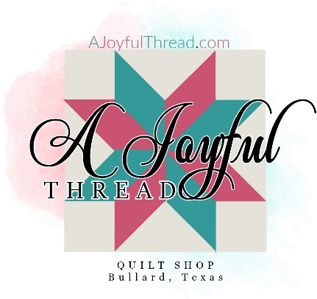
Illusions Quilt Workshop with Abby
Date: 5/25/2023
Time: 12:30-5:30
Skill Level: Beginner
Teacher: Abby Culbertson ~ sewtx@juno.com
Learn to make this stunning black & white quilt with a simple strip-piecing technique.

Requirements Checklist:
__ Working sewing machine you are familiar with and all machine feet.
__ rotary cutter
__ scissors
__ seam ripper
__ pins/wonderclips
__ rulers (we recommend Creative Grids rulers and you will need at least one that is 6 ½” x 24” and one additional ruler)

__ Cotton piecing thread, full bobbin
__ frixion marker.
__¼” Quilter’s foot
Optional: Stripology Ruler
All the above are available at A Joyful Thread

__Fabric Requirements:
Illusions Kit or:
One jelly roll (or forty two 2 ½ “ strips x 42”

3 Yards Background ****cut into 40 2 1/2” strips before class

5/8th Yards Binding (Not needed for class)
2 Yards 108” Fabric or 4 Yards 44” Backing (Not needed for class)

Pattern will be supplied in class.

