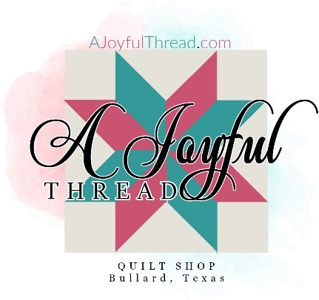
CHEERFUL Quilt using Strip Tube Ruler ~Workshop with Abby
Date: 6/15/2023
Time: 12:30-5:30
Skill Level: Beginner
Teacher: Abby Culbertson ~ sewtx@juno.com

Required:
__ Strip Tube Ruler
__ Working sewing machine you are familiar with and all machine feet.
__¼” Quilter’s foot
__ rotary cutter
__ scissors
__ seam ripper
__ pins/wonderclips
__ rulers (we recommend Creative Grids rulers and you will need at least one that is 6 ½” x 24” and one additional ruler)

__ Cotton piecing thread, full bobbin
All the above are available at A Joyful Thread online or in store.

__Fabric Requirements & Prep Work:
3/4 yard of 3 coordinating fabrics cut into 10 2 ½” strips each or 30 assorted 2 ½” strips (or a jelly roll!) **** must be cut before class
2 Yards Background ****cut into 10 6 ½” strips before class

5/8th Yards Binding (Not needed for class)
2 Yards 108” Fabric or 4 Yards 44” Backing (Not needed for class)

Pattern will be supplied in class.

