Beyond Scrappy August Block of the Month
Double Quartet

Guess what? August’s Block of the Month is the same construction method as the twisted sister (June’s Block.) The only difference is the layout of the block! How’s that for easy peasy?

For this month’s block you will need:
From black fabric: Four (4) 3 ½ inch squares
From white fabric: Four (4) 3 ½ inch squares
For half square triangles (HST) you will need 8 ½ inch white square AND 8 ½ inch lime square.
Cutting directions are in the chart below. We used the 12” since this is a 12 inch finished block. The fabric in your kit includes ample fabric.
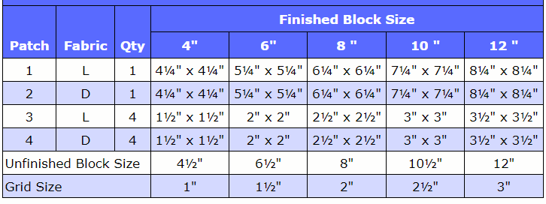
I cut my 3 ½ inch white and black squares and set those aside. You’ll use those for the final construction of the block.
To made the 8 HSTs that you need, I used the quick 8 method to make these. On the back of the 8 ¼ inch white square, draw a line from corner to corner. You will do the same to the opposing corners. You should have a drawn X. Layer the white and lime 8 ¼ inch squares right sides together. Pin if you wish. Stitch ¼ inch away from each side of the drawn line.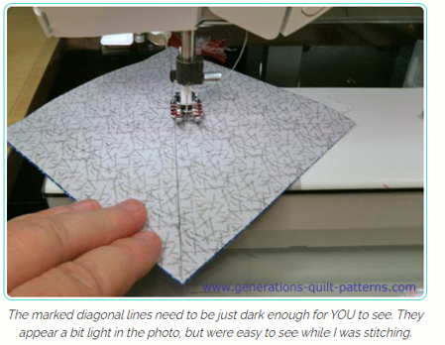
Alternate method (and my preferred): On the back of the white fabric, place the edge of your ruler ¼ inch away from each corner. Draw those lines from each corner. Rotate your fabric and do the same to the other side. You should have two lines from each corner, ¼ inch from the corners. Stitch just inside those drawn lines.
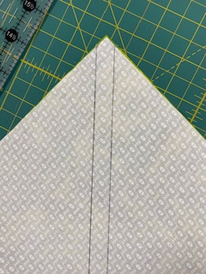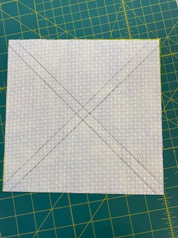

Cutting the Magic 8 HSTs apart:
With all seams sewn, make one cut vertical making sure you cut square through the center through the intersection. Rotate the block and make the second cut as the first, through the intersection again.
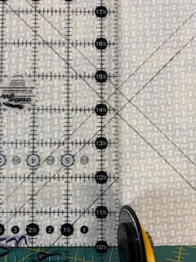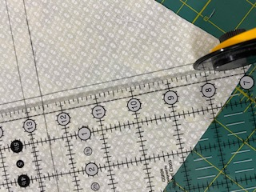
Once you’ve cut through both intersections, vertically and horizontally, you will cut between the stitched lines. You will then have 8 HSTs of lime and white. Press the seams to one side, either the lime or white. Trim each lime/white hst to 3 ½ inches.
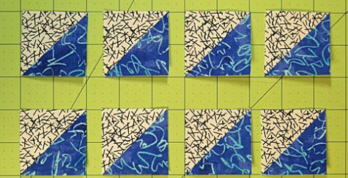
Layout your pieces with the black and white squares you cut earlier. Stitch together as shown below, keeping a ¼ inch seam throughout.
A suggested method of joining pieces together: (Shown with different fabrics, of course!)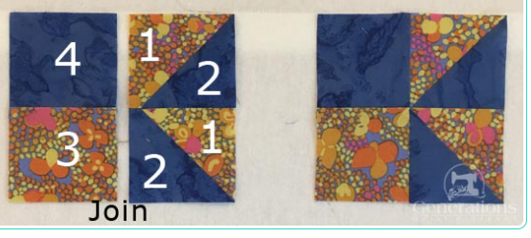

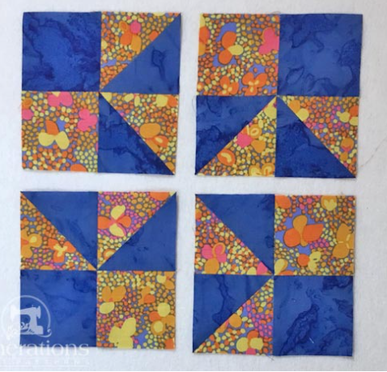
Assemble your 4 quadrants as shown above, stitch those together, and you have your completed Double Quartet Quilt Block!
