13 Weeks to All Hallows Eve
Week 2 - Hooty - 16" x 22"

Cutting Instructions: (Always cut the largest measurement first.)

Background -
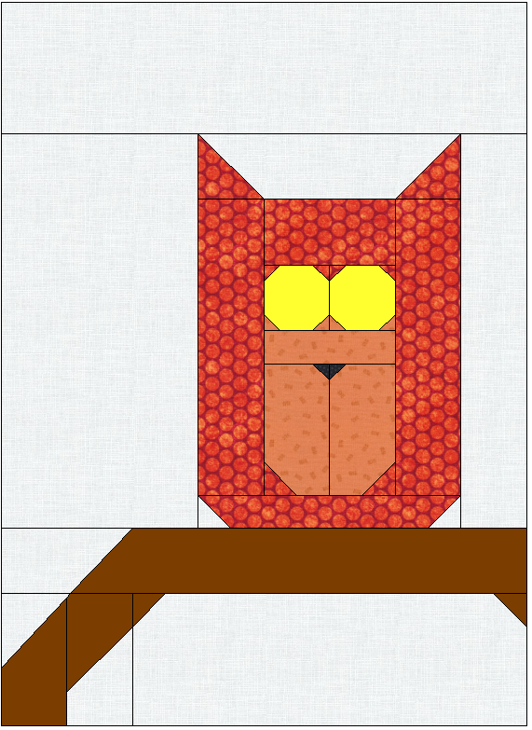
2 each 1-1/2" x 1-1/2" squares (FC)
1 each 2-1/2" x 2-1/2" square (FC)
1 each 2-1/2" x 3-1/2" rectangle (FCR)
1 each 2-1/2" x 4-1/2" rectangle (FCR)

1 each 2-1/2" x 8-1/2" rectangle (FC)
1 each 2-1/2" x 12-1/2" rectangle
1 each 4-1/2" x 12-1/2" rectangle (FC)
1 each 4-1/2" x 16-1/2" rectangle
1 each 6-1/2" x 12-1/2" rectangle
Brown -
2 each 1-1/2" x 1-1/2" squares (FC)
1 each 2-1/2" x 3-1/2" rectangle (FCR)
1 each 2-1/2" x 4-1/2" rectangle
1 each 2-1/2" x 14-1/2" rectangle (FCR)
Orange #1 - (Outside)
4 each 1" x 1" squares (FC)
2 each 1-1/2" x 1-1/2" squares (FC)
1 each 1-1/2" x 8-1/2" rectangle (FC)
2 each 2-1/2" x 2-1/2" squares (FC)
1 each 2-1/2" x 4-1/2" rectangle
2 each 2-1/2" x 9-1/2" rectangles
Orange #2 - (Inside)
(FC) Folded Corner Method
(FCR) Folded Corner Method with Rectangles

4 each 1" x 1" squares (FC)
1 each 1-1/2" x 4-1/2" rectangle
2 each 2-1/2" x 4-1/2" rectangles (FC)
Gold -
2 each 2-1/2" x 2-1/2" squares (FC)
Black -
2 each 1" x 1" squares (FC)
Section Construction -

Section 1 - Use the following pieces in Section 1 -

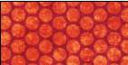
Orange #1 - 4 each 1" x 1" and 1 each 2-1/2" x 4-1/2".
Orange #2 - 4 each 1" x 1".
Gold - 2 each 2-1/2" x 2-1/2".

1. Lay out each piece as shown in Section 1. Using the
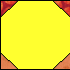
Folded Corner Method outlined in previous blocks, place a
square on the appropriate unit corner and sew on the
diagonal line. Press and trim. Sew the section pieces
together for Section 1.
Section 1

Section 2 - Use the following pieces in Section 2 -

Orange #1 - 2 each 1-1/2" x 1-1/2".
Orange #2 - 1 each 1-1/2" x 4-1/2" and 2 each 2-1/2" x 4-1/2".
Black - 2 each 1" x 1".

1. Lay out each piece as shown in Section 2. Using the
Folded Corner Method outlined in previous blocks, place a
square on the appropriate unit corner and sew on the
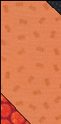
diagonal line. Press and trim. Sew the section pieces
together for Section 2.

Sew Section 1 to Section 2. This creates
Hooty's Core Section.

Section 2

Section 3 - Use the following pieces in Section 3 -

Hooty's Core Section
Background - 2 each 1-1/2" x 1-1/2" and 1 each 2-1/2"x 8-1/2".
Orange #1 - 1 each 1-1/2" x 8-1/2", 2 each 2-1/2" x 2-1/2" and 2 each 2-1/2" x 9-1/2".

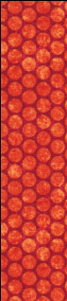
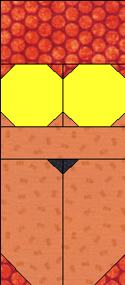
1. Lay out each piece as shown in Section 3. Using the Folded Corner Method outlined in previous blocks, place a square on the appropriate unit corner and sew on the diagonal line. Press and trim. Sew the section pieces together for Section 3.

Section 4 - Use the following pieces in Section 4 -

Background - 1 each 2-1/2" x 4-1/2".
Section 3
Brown - 1 each 2-1/2" x 14-1/2".
4-1/2" 8-1/2"
1. Lay out each piece as shown in Section 4. Using the Folded Corner Method using Rectangles outlined in previous blocks, place a rectangle on the appropriate unit corner and sew on the diagonal line. Press and trim. Sew the section pieces together for Section 4.

Section 4

Section 5 - Use the following pieces in Section 5 -
Background - 1 each 2-1/2" x 2-1/2", 1 each 2-1/2" x 3-1/2" and 1 each 4-1/2" x 12-1/2".
Brown - 2 each 1-1/2" x 1-1/2", 1 each 2-1/2" x 3-1/2" and 1 each 2-1/2" x 4-1/2".
4-1/2" 8-1/2"
1. Lay out each piece as shown in Section 5. Using the Folded Corner Method and the Folded Corner Method using Rectangles
Section 5
outlined in previous blocks, place a square or rectangle on the appropriate unit corner and sew on the diagonal line. Press and trim. Sew the section pieces together for Section 5.
Block Construction -
4-1/2" x 16-1/2"
Section 3

1. Using the diagram below,

sew the Sections together
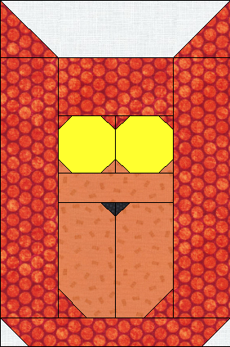
with the additional
2-1/2" x 12-1/2",
4-1/2" x 16-1/2" and
6-1/2" x 12-1/2"
2-1/2" x 12-1/2"
6-1/2" x 12-1/2"
background pieces to complete the Hooty Block.

Section 3
Section 4

Section 5

* * * CORRECTION * * *

The sample maker/verifier was delayed in the sample and found an error. Please replace Pumpkin #2 instructions with the following:

Cutting Instructions: (Always cut the largest measurement first.)

Background -
1 each 1-1/2" x 2-1/2" rectangle
2 each 2-1/2" x 2-1/2" squares (FC)
1 each 3-1/2" x 4-1/2" rectangle
1 each 3-1/2" x 6-1/2" rectangle
1 each 4-1/2" x 4-1/2" square (FC)
Orange -
1 each 9-1/2" x 10-1/2" rectangle (FC)
Brown (Tree) -
1 each 1-1/2" x 4" rectangle
1 each 1-1/2" x 5" rectangle
3 each 2-1/2" x 2-1/2" squares (FC)
1 each 2-1/2" x 3-1/2" rectangle
1 each 3-1/2" x 4-1/2" rectangle (FC)
1 each 4-1/2" x 8-1/2" rectangle (FC)
Green -
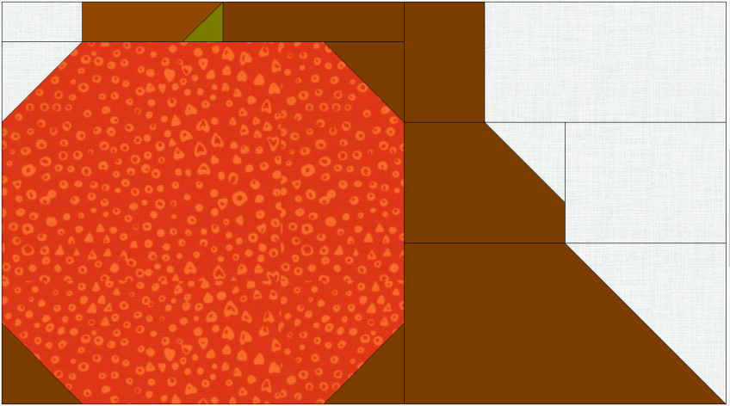
1 each 1-1/2" x 1-1/2" square (FC)

(FC) Folded Corner Method

Section Construction -
Section 1
Section 1 - Use the following pieces in Section 1 -
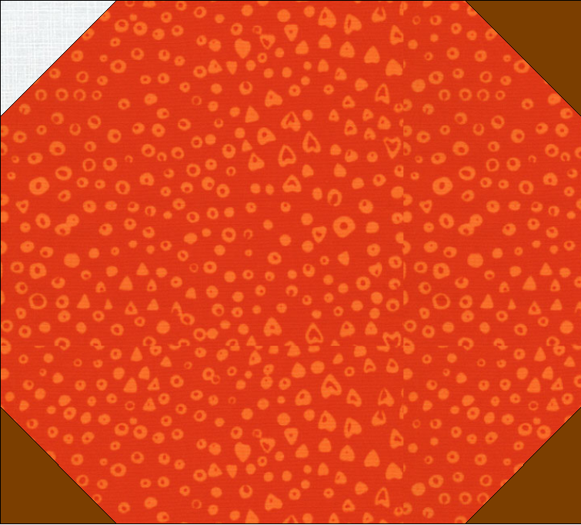
Background - 1 each 1-1/2" x 2-1/2" and
1 each 2-1/2" x 2-1/2"
Orange - 1 each 9-1/2 x 10-1/2"
Brown - 1 each 1-1/2" x 4", 1 each
1-1/2" x 5" and 3 each
2-1/2" x 2-1/2"
Green - 1 each 1-1/2" x 1-1/2"

1. Lay out each piece as shown in Section 1. Using the Folded Corner Method outlined in previous blocks, place a square on the appropriate unit corner and sew on the diagonal line. Press and trim. Sew the section pieces together for Section 1.

Section 2 - Use the following pieces in Section 2 -
Section 2

Background - 1 each 2-1/2" x 2-1/2", 1 each
3-1/2" x 4-1/2", 1 each 3-1/2" x 6-1/2" and
1 each 4-1/2" x 4-1/2"
Brown - 1 each 2-1/2" x 3-1/2", 1 each 3-1/2" x 4-1/2" and 1 each 4-1/2" x 8-1/2"
4-1/2" 8-1/2"
1. Lay out each piece as shown in Section 2. Using the Folded Corner Method outlined in previous blocks, place a square on the appropriate unit corner and sew on the diagonal line. Press
and trim. Sew the section pieces together for Section 2.

Block Construction -
Section 3

1. Using the diagram below, sew the Sections together to complete the Pumpkin #2 Block.

Section 2
Section 1

