Brighter Days
Week 12 – Finishing
82” x 98”
Brighter Days are here, and this is the final week. You will be piecing five large sections to create your quilt top. You have already pieced the “Sunshine” section. You will need 1-5/8 yards for the final border. Choose something that brings your Brighter Days together. Mine, of course, will be RED.
Cutting Instructions:
Background: 8 each 6-1/2” x 6-1/2” squares, 1 each 6-1/2” x 9-1/2” rectangle, 3 each 6-1/2” x 12-1/2” rectangles and 2 each 6-1/2” x 18-1/2” rectangles.
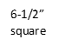
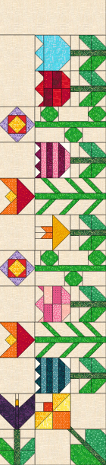
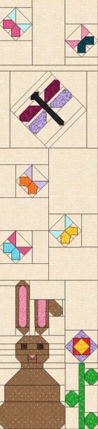
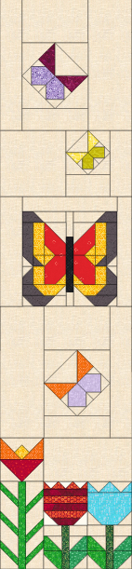
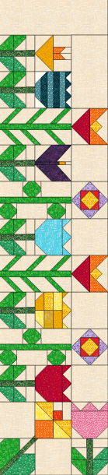
6-1/2” x 9-1/2”
6-1/2” x 12-1/2”
6-1/2” x 12-1/2”
6-1/2” x 12-1/2”
6-1/2” square
6-1/2” x 18-1/2”
6-1/2” x 18-1/2”
1. Once all Sections are completed, piece all Sections together as shown below.

Outer Border Cutting Instructions: 9 each 5-1/2” x WOF

1. Using your border technique, add Borders to complete as shown below.
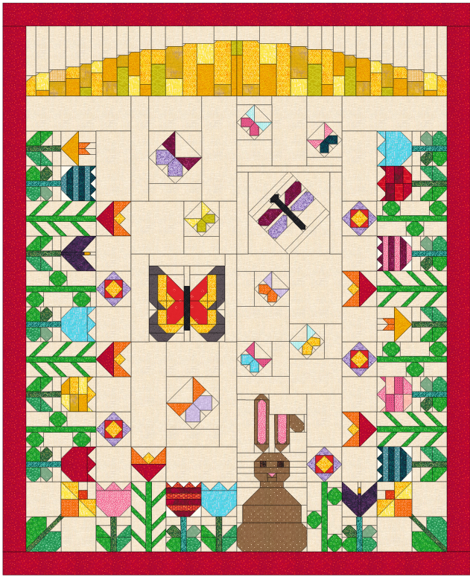

Hope you have enjoyed this Brighter Days Quilt.
Kennette

