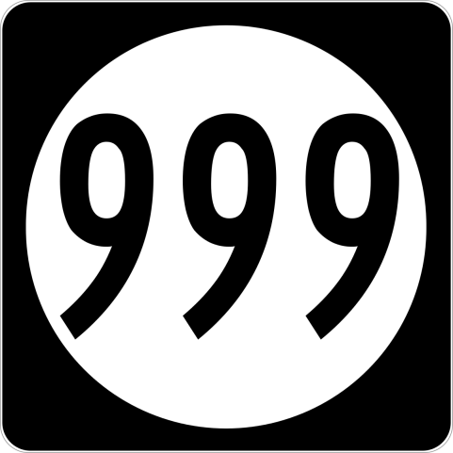



Something To Crow About

4227-C Main Street

Springfield, OR 97478 - 541-746-3256

stca@somethingtocrowabout.com

**999 Project**

**Block 8**

Cutting Requirements:

Background:

4 each 2" x 2" squares

2 each 2" x 3-1/2" rectangles (FC)

4 each 2-3/8" x 2-3/8" squares, cut

once diagonally

1 each 4-1/4" x 4-1/4" square, cut

twice diagonally

Medium #1 - Red

8 each 2" x 2" squares (FC)

4 each 2-3/8" x 2-3/8" squares, cut

once diagonally

Medium #2 - Med. Blue

2 each 3-7/8" x 3-7/8" squares, cut

once diagonally

Dark - Dark Blue

1 each 3-1/2" x 3-1/2" square

FC - Folded Corners