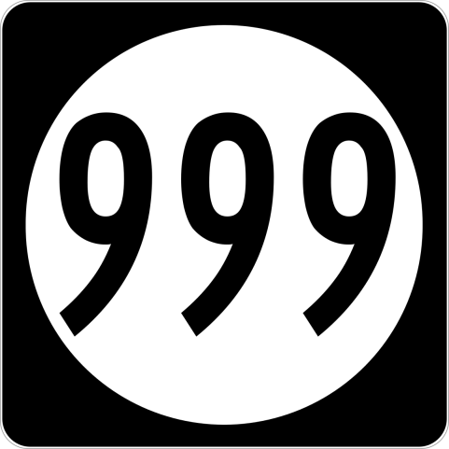



Something To Crow About

4227-C Main Street

Springfield, OR 97478 - 541-746-3256

stca@somethingtocrowabout.com

**999 Project**

**Block 4**

Cutting Requirements:

Background:

16 each 1-5/8" x 1-5/8" squares

4 each 3-1/8" x 3-1/8" squares, cut

once diagonally

Medium - Red

16 each 1-5/8" x 1-5/8" squares

Dark - Dark Blue

4 each 3-1/8" x 3-1/8" square, cut

once diagonally