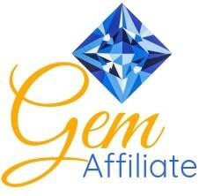
Class Description: Birthstone Gem Series
Birthstone Gem Series

Create your own sparkling gem using the same techniques that artist and designer MJ Kinman has used to create her giant gem quilts for over 20 years.
MJ has created patterns that allow all of us to bring a little bling into our lives. Through her use of color and contrast, MJ has created patterns that will delight your senses and are a blast to put together even for the new quiltmaker.
This isn’t your typical foundation paper piecing. Freezer paper templates are ironed to the RIGHT side, so there is no confusing reverse piecing; templates are easily removed and REUSABLE, so there are no paper bits to pull from the back of the quilt; reduces fabric waste since there is no flip-and-sew method used. And best of all, these patterns don’t require absolute precision, so you can relax and enjoy every aspect of making your gem.
Makes wonderful Mother's Day quilts (featuring family birthstones), baby quilts (featuring Baby's birthstone), birthdays, weddings, and many more.
Join Tina Hoss, certified Gem Affiliate with MJ Kinman, Textile Artist, and add a little bling to your life by creating your own gemstone!
Skill Level: Confident Beginner Supply List:

- Business-sized envelopes (10)
- Rotary cutter and mat
- Rulers (with ¼” measurements)
  - 18” ruler (any width)
  - 6” x 2.5” ruler
- Basic sewing supplies
- Seam ripper
- Tweezers
- Wonder Clips (10-15)
- Fabric marking pencils (light & dark)
- Basic sewing machine with back-stitch capability
- Optional supplies (but very helpful)
  - Stiletto
  - Rotating cutting mat
  - Extra rotary cutter with blade (for cutting the paper template)
  - Highlighter

