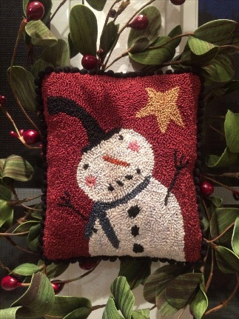

Meet marshmallow
Punch Needle Design by tina payton

Please print legibly! One registrant per form.

Name: __________________________ Address: _____________________________________
City: __________________________________ State: _______________ Zip: ______________
Phone: __________________________ Email: _______________________________________
DOB: ___________________________

Class Date:
December 1st or 8th - Saturday 10:30 – 3:30 pm
FEES:
Class Fee: (non-refundable) $55.00 due upon registration
Marshmallow is an out of print punch needle design. Thanks to Tina Payton we’re offering in shop classes on December 1st and Dec 8th. Class includes – design pre-drawn on weaver’s cloth, kitted with 3 strand Valdani/DMC threads. Lunch, bottled water and coffee provided.
Checks, cash or credit cards are forms of payment. Credit Card payments will be charged an additional 4% to cover processing fees.
Credit Card Number (neatly) __________________________________________________________
Exp. Date _______________ Security Code ____________ Billing Zip Code for card ______________
Needed items for class are: our favorite is a 7"x 9" Morgan Lap Stand $46.00 along with a quality 3 strand punch needle and threader, our favorite is the Ultra Punch Needle Set $27.50. Both are available in the shop please let us know if you’d like to reserve one. You’ll also need a pair of curved scissors. We have 4 options in the shop for you to choose from.
I have read and understand all cancellation/non-refundable dates/policies.

Signature: __________________________________________ Date: ____________________
email – annt1959@sbcglobal.net or call 501-221-6990
Email will be sent to notify you as a registered workshop attendee.

