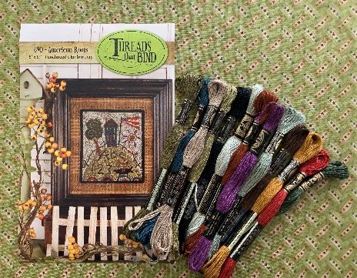

Intermediate Punch needle
March 16th - Saturday

Please print legibly! One registrant per form.

Name: ________________________________ Address: _____________________________________
City: __________________________________ State: _______________ Zip: ______________
Phone: __________________________ Email: _______________________________________
DOB: ___________________________

Class Date:
March 16th - Saturday 10:30 – 3:30 pm
FEES:
Class Fee: (non-refundable) $75.00 due upon registration
You will learn to use Misty Fuse to fuse Blackbird Moda Fabric to the weaver’s cloth and punch through the fabric creating a beautiful border for your finished piece. Class fee includes the pattern printed on weaver’s cloth, DMC threads, Blackbird Moda Fabric, Misty Fuse, and lunch

Checks, cash or credit cards are forms of payment. Credit Card payments will be charged an additional 4% to cover processing fees. ($3.00)
Credit Card Number (neatly) __________________________________________________________
Exp. Date _______________ Security Code ____________ Billing Zip Code for card ______________
Needed items for class are: our favorite is a 7"x 9" Morgan Lap Stand $46.00 along with a quality 3 strand punch needle and threader, our favorite is the Ultra Punch Needle Set $27.50. Both are available in the shop please let us know if you’d like to reserve one. You’ll also need a pair of curved scissors. We have 4 options in the shop for you to choose from.
I have read and understand all cancellation/non-refundable dates/policies.

Signature: __________________________________________ Date: ____________________
email – ann@shepherdsneedle.com or call 501-221-6990
Email will be sent to notify you as a registered workshop attendee.

