Fabric Collage Two Day Workshop with Linda Hasselberg

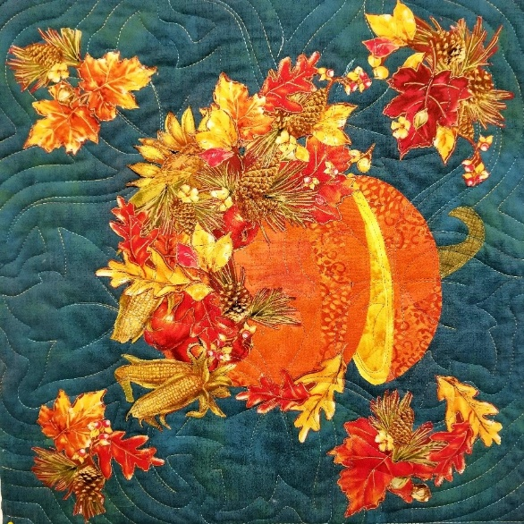
Dates: March13-14, 2026
Time: 10:30 am – 4:00 pm
Place: Uptown Blanco Retreat House,
514 3rd Street, Blanco
Instructor: Linda Hasselberg
Cost: $70.00

Bring any collage pattern (Laura Heine, Emily Taylor, Susan Carlson, Linda Hasselberg or any other) to this workshop. You will learn how to tackle the use of color and contrast to create dimensionality in your collage creation.
What to bring:
- Karen K. Buckley serrated-edge scissors or other fine serrated scissors
- Foundations and/or Backgrounds (which are explained in the video referenced below)
- Your choice of temporary marking pen, fine-tip sharpie or mechanical pencil
- Applique Pressing Sheet (parchment paper can be used, but the pressing sheet is better, in my opinion)
- Glue (any fabric-safe permanent glue is okay, but I use Alleen's fabric fusion)
- Lite Steam-A-Seam 2 (patterns offer suggested amounts)
- Rotary Cutter and Long ruler if you are doing one of the “painterly” patterns, such as The Guardian angel.
- No sewing machine is required or needed for the workshop unless you need to sew together your background for Cora the Owl or similar patterns.

Homework: Recommended amount of Light Steam-a-Seam 2 for preparing and fussy-cutting flowers and other motifs prior to class. Watch Linda’s No Rules: Prep for Collage class video at –
https://youtu.be/SRgvgIfok14?si=1nL2bPZolA77Eqp2

Optional Supplies:
- Lightbox – very helpful

Rules:
- NUMBER ONE RULE – There are no rules, only techniques and creativity. Please dispose of all the “I can’ts”, I don’t know hows”, and “I;m not creatives” before coming to class. You can! You will learn! You are creative!
General Information:
- A 10% discount will be provided for supplies purchased for the workshop.
- A lunch break will be provided, bring your own lunch or plan on ordering from one of the local restaurants
- The Retreat House provides two ironing stations and two cutting stations.
- If you wish to stay overnight at the Retreat House, the cost would be $75.00. Please call either Tory Padden or Ruth Johnson at the Textile Studio to book the overnight stay for this workshop.

