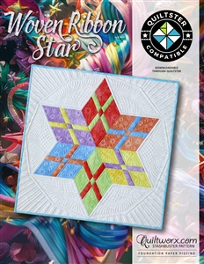
Woven Ribbon - Two-Day Paper Piecing Workshop
Time: 10 am – 4: 30 pm
Place: Uptown Blanco Retreat House, 514 3rd Street, Blanco
Instructor: Vida Anderson, Quiltworx Certified Instructor
Cost: $70.00
Woven Ribbon Star is a perfect beginner pattern using the Quiltworx foundation paper piecing method. This pattern makes a 30" X 30" table topper/wall hanging. This is a two-day workshop.
Fabric Requirements:
Background: 1/4 yard
Star: 6) Fat Eighths - great for a rainbow layout as pictured
Or Choose Two Coordinated Fabrics 1/4 yard each to alternate star points.
- Fabric 1: 1/4 yard and,
- Fabric 2: 1/4 yard
Required Supplies:
- Woven Ribbon Pattern
- Add-A-Quarter Ruler
- Fabric Glue and Refills: 1) Fabric Glue Pen such as Sue Daily, SewLine etc. for paper piecing AND 1) Repositionable Glue Stick such as 505 for placing your first fabric.
- Sewing machine, seam ripper, pins, bobbin & thread
- ¼” foot for your sewing machine, or know how to adjust your machine for ¼” seam
- Rotary cutter with 45 mm blade preferred
- Microtex 70/10 Needle
- 50 or 60 wt thread

Recommended but not required:
- Acorn Pressing Pens and Refill Solution
General Information:
- A 10% discount will be provided for any products or supplies purchased for the workshop. Please plan on arriving prior to 10 am to set up and be ready to go
- A lunch break will be provided, bring your own lunch or plan on ordering from one of the local restaurants
- The Retreat House provides two ironing stations. You may bring a small portable iron and ironing mat if you prefer
OPTIONAL:
If anyone is interested in staying at the Retreat House overnight for the workshop, the cost would be $75.00 per person. That includes all taxes.

