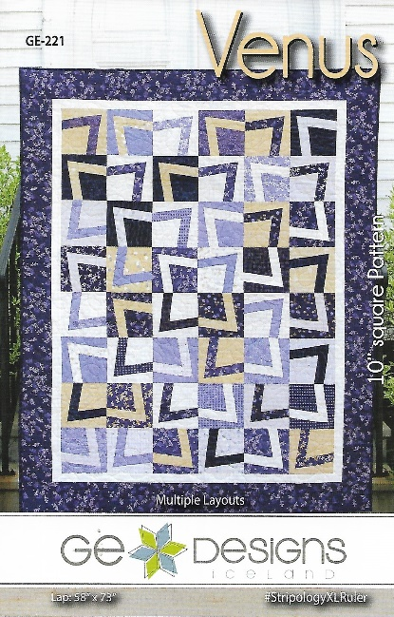
Venus Workshop
Time: 10 am – 4: 30 pm
Place: Uptown Blanco Retreat House, 514 3rd Street, Blanco
Instructor: Ruth Johnson, Certified Stripology Instructor
Cost: $35.00
Make a striking geometric quilt top using the Venus pattern by GE Quilt Designs. Designed for 10" assorted squares or 10” squares and a single background. The pattern has 4 different layout options and 5 different sizes. It is recommended that either the Stripology XL or Stripology Squared ruler is used, though directions for using regular rulers will be provided.
Fabric Requirements:
- Based on your preferred finished quilt size, refer to the pattern for fabric requirements
Required Supplies:
- “Venus” pattern by GE Designs, every participant must have their own patten, no sharing is allowed
- Sewing machine and usual sewing supplies such as seam ripper, pins, bobbin & thread
- ¼” foot for your sewing machine, or know how to adjust your machine and needle to get a scant ¼” seam
- Rotary cutter with 45 mm blade preferred (18 mm and 28 mm rotary blades do not work well with the Stripology rulers)
- Stripology Squared or Stripology XL ruler (or regular 24” long ruler)
Recommended but not required:
- As you will be working with bias cuts, it is highly recommended that you prep your fabric with Faultless Magic Quilting & Crafting Spray or Mary Ellen’s Best Press or your favorite fabric starch; please do this prior to the workshop
- GEasy Clips and GEasy Stickers
General Information:
- A 10% discount will be provided for any Stripology, GE Design products or other supplies purchased on the day of the workshop. Please plan on arriving prior to 10 am to set up and be ready to go
- A lunch break will be provided, bring your own lunch or plan on ordering from one of the local restaurants
- The Retreat House provides two ironing stations. You may bring a small portable iron and ironing mat if you prefer

