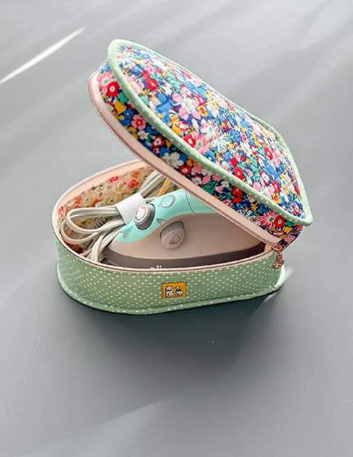
Travel Case for Mini Iron by Minki Kim Workshop
Time: 10:00 am – 4: 30 pm
Place: Uptown Blanco Retreat House, 514 3rd Street, Blanco
Instructor: Lucy Blum
Cost: $45.00
Learn to make this Travel Cas for Mini Iron by Minki Kim! Learn helpful tricks and tricks to personalize your travel iron case. Be the envy of your quilting group or at quilt retreats! Finished size is 9.5” X 5.5” X 5”.
Fabric Requirements:
- Fabric A – Fat Quarter
- Fabric B – Fat Quarter
- Lining Fabric – ½ yard
- Foam Stabilizer – ½ yard (Bosal In-R-Foam Single Sided Fusible Form or Soft and Stable)
- Zipper – 22” Double-Slide (#4 nylon zipper)
- 1” wide webbing – 10”
Required Supplies:
- Sewing machine
- Sewing supplies: seam ripper, pins, bobbins, clips & thread
- Fabric and paper scissors
Optional Supplies:
- Mini Iron
- Small Ironing mat
General Information:
- A 10% discount will be provided for any products or supplies purchased for the workshop. Please plan on arriving prior to 10 am to set up and be ready to go.
- A lunch break will be provided, bring your own lunch or plan on ordering from one of the local restaurants
- The Retreat House provides two ironing stations. You may bring a small portable iron and ironing mat if you prefer

OPTIONAL:
If anyone is interested in staying at the Retreat House overnight for the workshop, the cost would be $75.00 per person. That includes all taxes.

