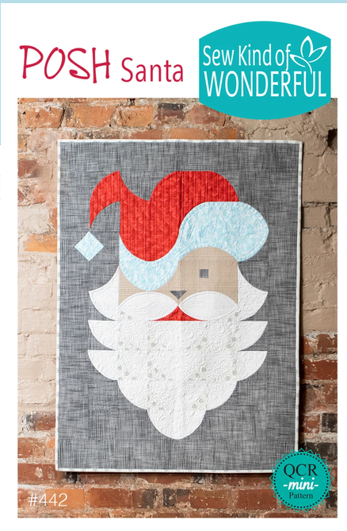

Posh Santa Wall Hanging Workshop (from Sew Kind of Wonderful)

Time: 10:00 am – 2:00 pm

Place: Uptown Blanco Retreat House, 514 3rd Street, Blanco, TX

Instructor: Debbie Hyde

Cost: $40.00

Finished size: 28” x 38”

Learn how to use your QCR Quick Curve Mini Ruler to make this jolly Santa wall hanging that is full of personality with his floppy hat and stylish beard! Just the right size for an easy weekend holiday project. He would make a great door quilt to greet all holiday guests. Come and learn something new with a small, completable Christmas wall hanging.
Fabric Requirements:

- 1 fat quarter for hat main fabric (red)
- 1 fat quarter for hat trim fabric (white or light blue as shown on pattern)
- 1 fat quarter for face fabric (light pink, peach, neutral)
- 2/3 yard beard main fabric (white)
- ¼ yard beard secondary fabric (white or white print)
- (2) 5” squares for mouth fabric (red)
- (1) 5” square for nose/eye fabric (gray)
- 1 ¼ yards background fabric (gray or your choice)
- 1 yard backing
- ½ yard binding
Cut and LABEL fabrics their length and width as directed in the pattern.

Watch your beard fabrics, you need two CONTRASTING fabrics.

Required Supplies:

- Sewing machine, power cord, foot pedal
- Quick Curve Mini Ruler (available for purchase at Uptown Blanco Textile Studio)
- Posh Santa Pattern (available for purchase at Uptown Blanco Textile Studio)
- Reminder: Cut and LABEL the fabric the length and width dimensions as directed in the Posh Santa Pattern. You will learn to use the Quick Curve Mini Ruler in class for the specific Santa pieces.
- Sewing supplies: seam ripper, pins, bobbins, clips & thread
- 45 mm rotary cutter, and cutting mat

General Information:
- A 10% discount will be provided for any products or supplies purchased for the workshop. Please plan on arriving prior to 10 am to set up and be ready to go.
- A lunch break will be provided, bring your own lunch or plan on ordering from one of the local restaurants
- The Retreat House provides two ironing stations. You may bring a small portable iron and ironing mat if you prefer

