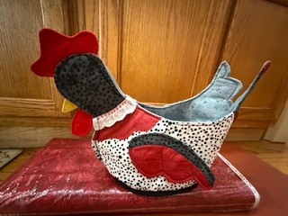
Plucky Chicken Basket Workshop
Finished Size: Approximately 19” X 13”
Time: 10:00 am – 5:00 pm
Place: Uptown Blanco Retreat House, 514 3rd Street, Blanco
Instructor: Tracey Puig
Cost: $50.00 (includes pattern(s)
This little Chick is ready to help out when she can! She would like nothing better than to hold warm dinner rolls wrapped in a towel on your dinner table. She can hold your yarn and knitting or crochet needles for you helping to keep your project all in one place. Put your silverware and paper towels in her basket for a table outside at a BBQ. She's not just a little workhorse, she can also be quite pretty with a vase and some flowers set in her little basket as a pretty decoration. This little Chicken will brighten your table or help you stay organized all the while looking cute as can be.
Fabric Requirements:
- Main Fabric – 5/8 yard for main body, wings, and bottom
- Second Fabric – 22” X 22” for head, tail, and wing
- Third Fabric - ¾ yard for neck, wings, and tail
- Fourth Fabric – 20” x 22” for lining, and bottom piece
- Fifth Fabric - Red Fabric – One 12” x 12" square piece for 2 waddles and two combs
- Sixth Fabric - Yellow Fabric- 2 pieces 5" x 5"

Required Supplies:
- Sewing Machine
- 1 ½ yards fusible fleece or batting or fusible foam
- 2 buttons for eyes (at least 7/16)
- ½” Extra Wide Double Fold Bias Tape - 1 pack
- Heat and Bond or Steam-A-Seam - 12" w x 20
- Pins and/or clips
- Scissors
- 24” ruler
- Jean needle 90/14
- Open-toe applique foot
- 1/4" Piecing foot
- Matching or complementary thread
- Turning tool
- Applique pressing sheet or parchment paper
- Hand sewing needle

Recommended but not required:
- Neck Decoration – Choose one of the following:
  - Lace – 2 pieces 1" to 1.5” w X 6.5” l
  - ric rac - .5" w to 1" w x 6.5 l
  - ribbon - no wider than 1.5" w x 6.5" l
- Fabric glue
- Walking foot (Nice but not necessary)
- Travel Iron

General Information:
- A 10% discount will be provided for supplies purchased for the workshop.
- A lunch break will be provided, bring your own lunch or plan on ordering from one of the local restaurants
- The Retreat House provides two ironing stations and two cutting stations.

