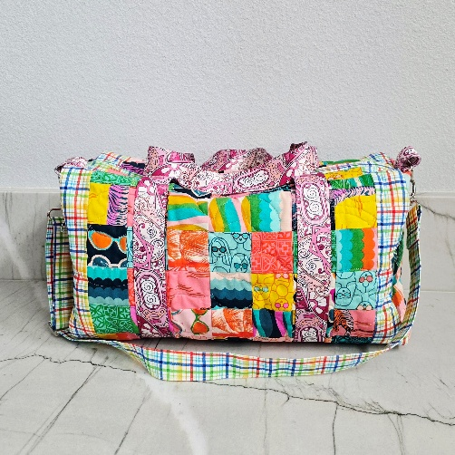
Patchwork Duffle Mini Workshop
Finished Size: 10'' H 17.5'' W x 8.5'' D
Time: 10:00 am – 4:30 pm
Place: Uptown Blanco Retreat House,
514 3rd Street, Blanco
Instructor: Liz Kuntz
Cost: $57.00
The Patchwork Duffle Mini is a great bag for weekend travel or just makes a great everyday duffle bag to tote your favorite things to a sports game. This duffle features a patchwork exterior (or make it with your favorite fabric in a one-fabric version) and a large opening. It has exterior pockets on the ends of the bag. It's a great companion duffle for your large bag, and also the perfect size for packing your favorite items.
Pattern is required for workshop and is part of the workshop fee when you sign up for the class online or at the Textile Studio. The pattern can be mailed to you or available for pick up prior to the workshop so that you can assemble the patchwork and quilt the pieces prior to taking the class so on the day of the workshop can be spent sewing and putting together the duffle bag. It is encouraged to make the bag using one fabric to learn the bag construction, but please make the patchwork option if that is the option you want to make on the day of the workshop.
- If making the patchwork option, please have your patchwork squares sewn together according to the suggested pattern dimensions prior to the class. You will quilt the pieces of the duffle bag prior to the construction.
The Patchwork Duffle Mini information:
Size finishes at 17.5” width x 10" height x 8.5" Depth
Main Fabric
Lining Fabric
Interior Accent (Bias Binding)
Exterior Accent (Exterior Bindings, Handle, and Carrying Strap)
Zipper for Duffle closure
Bag Hardware
Fabric Requirements:
Main Fabric - 1 yard for One Fabric Version or
12 Fat Eighths or Scraps for Patchwork Version
Batting – 1 yard (can use batting or soft and stable)
Lining Fabric – 1 yard (does not account for directional lining)
Interior Accent (Bias Binding) – Fat quarter
Exterior Accent (Exterior Bindings, Handle, and Carrying Strap) – 2/3 yard or ¼ yard if using decorative webbing for the handles and carrying strap
If using webbing: Handle: 106 “
Hardware tabs: 8”
Carrying Strap: 63”
Zipper for Duffle closure – (1) 24” double slide handbag zipper
Bag Hardware – (2) 1 ½” Triangle-rings
(2) 1 ½” Swivel Hooks
(1) 1 ½” Strap Adjuster
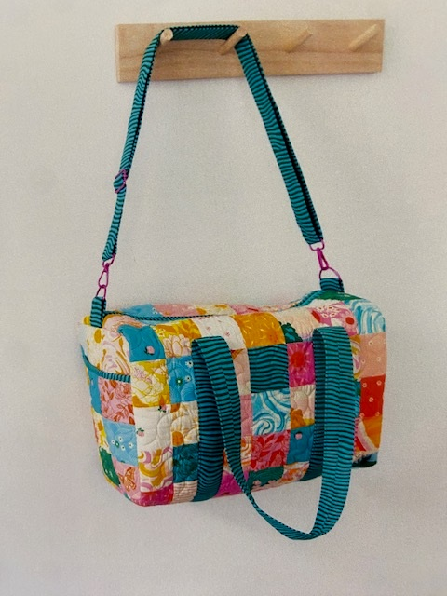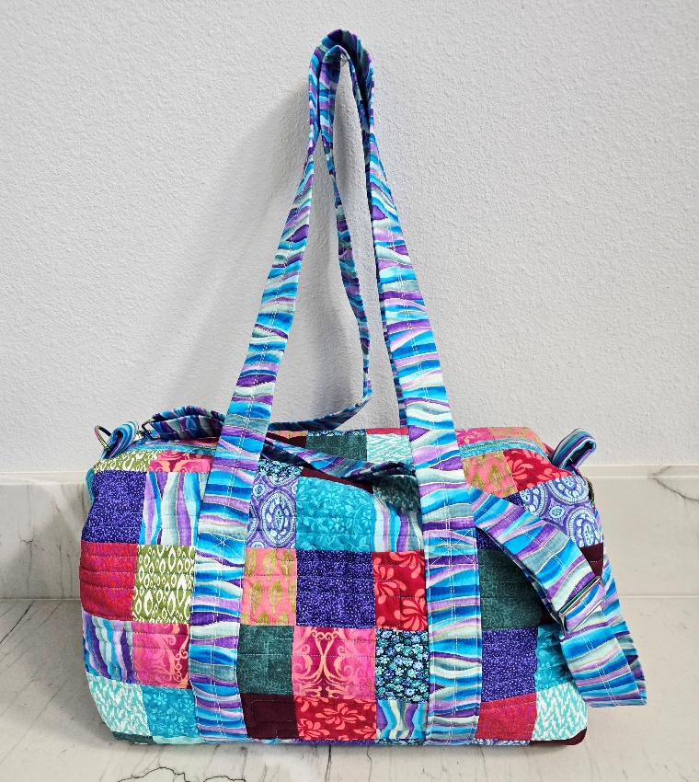
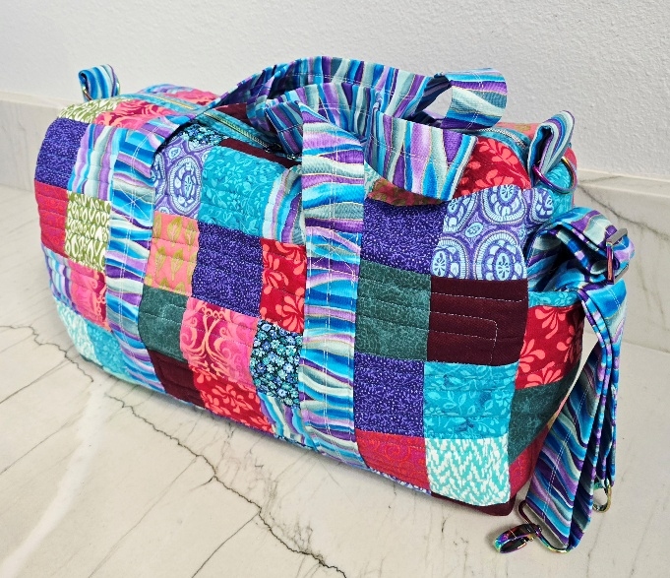
Required Supplies:
- Sewing Machine and foot pedal
- Thread to match your fabric(s)
- Clips and pins
- Zipper foot & ¼” foot
- Fabric marking pen/marker (disappearing ink type by water/air/heat)
- Scissors/Rotary Cutter

Recommended but not required:
- Walking foot (Nice and very helpful, but not required)
- Travel Iron/mat
- 18” X 24” Cutting Mat

General Information:
- A 10% discount will be provided for supplies purchased for the workshop.
- A lunch break will be provided, bring your own lunch or plan on ordering from one of the local restaurants.
- The Retreat House provides two ironing stations and two cutting stations.

