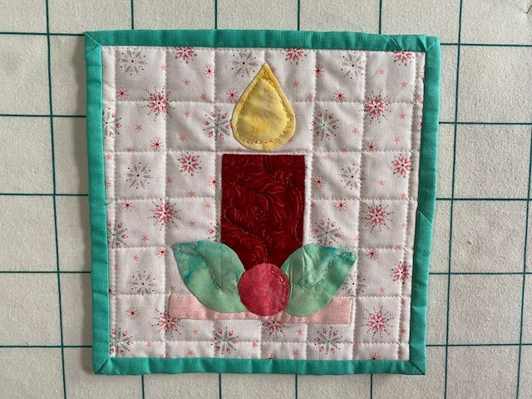
Introduction to Turned Applique

Time: 1:00 pm – 4:00 pm

Place: Uptown Blanco Retreat House, 514 3rd Street, Blanco

Instructor: Linda Hasselberg

Cost: $40.00

Finished size: 8” X 8” quilt block

Learn how to do turned applique with the back-basting method in this one-day workshop creating an 8" X 8" quilt block.

Fabric Kit is provided with the registration fee. (Includes background and applique fabrics for the 8” X 8” quilt block)

Required Supplies:
- Sewing machine, power cord, foot pedal
- Karen Kay Buckley scissors, or scissors labeled for applique work will be ok too.
- Size 10 or 11 Straw Needles, (also known as Milliner’s needles)
- Sewing supplies: seam ripper, pins, bobbins, clips & thread

- Historical note – Straw needles also commonly known as milliner’s needles, are extra-long hand-sewing needles with a sharp point, a small round eye, and a uniform shaft. They get their name “straw” because they were historically used in traditional straw-hat making.

General Information:
- A 10% discount will be provided for any products or supplies purchased for the workshop. Please plan on arriving about 15 minutes prior to 1:00 pm to set up and be ready to go.
- The Retreat House provides two ironing stations. You may bring a small portable iron and ironing mat if you prefer.

