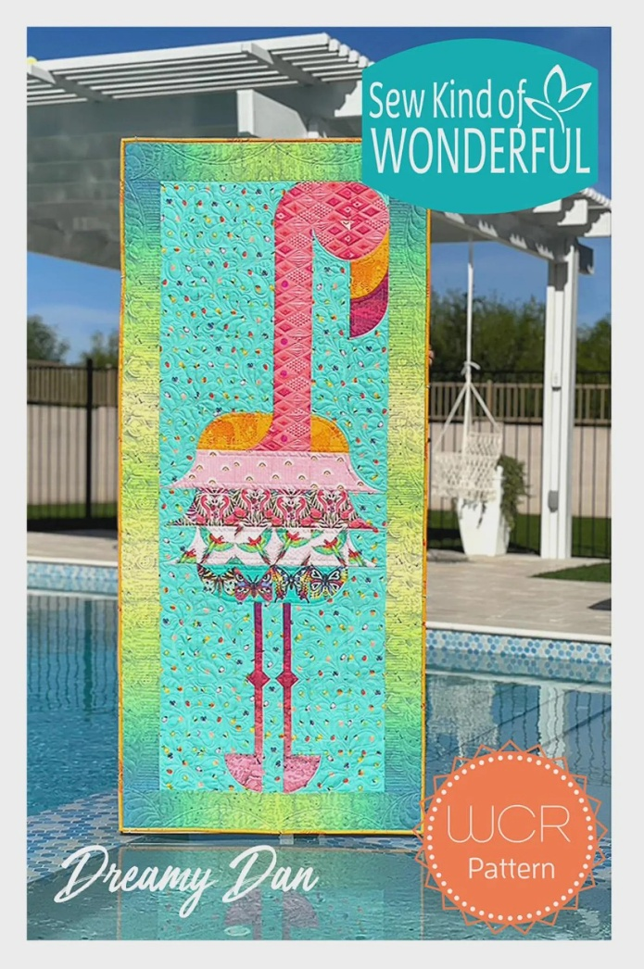
Wonder Curve Ruler Project –
Dreamy Dan Flamingo (28” X63”)
Time: 1:00 am – 5:00 pm
Place: Uptown Blanco Retreat House, 514 3rd Street, Blanco
Instructor: Debbie Hyde
Cost: $30.00
Join Debbie Hyde (a certified Sew Kind of Wonderful Instructor) to learn how to use Wonder Curve Ruler like a pro! She'll show you all of the tips and tricks and with her assistance you'll start a Flamingo wall hanging using the Dream Dan Flamingo pattern. You will be making the head and the neck down to the shoulders.
Please come with your fabric pre-cut BEFORE class as stated on page 3. Please follow the directions written in orange, you will be working with larger pieces in place of several smaller squares. Be sure to label fabrics:
- head & neck fabric
- orange body/beak fabric
- pink eye/body fabric

Fabric Requirements for block you are making in workshop:
- Seven ¼ yard cuts assorted fabrics for flamingo
- 1 ¼ yards background fabric
- 2/3 yard border fabric
- ½ yard binding fabric

Supplies Required:
- Dreamy Dan Flamingo Pattern (available at the Textile Studio)
- Multiple Wonder Curve Ruler (Available at the Textile Studio)
- 45 mm rotary cutter
- Small cutting mat
- Basic sewing supplies (i.e., pins, seam ripper, thread, snips, etc.)

General Information:
- The Retreat House provides two ironing and two cutting stations for your convenience.
- A 10% discount will be provided for products or other supplies purchased for the workshop.

