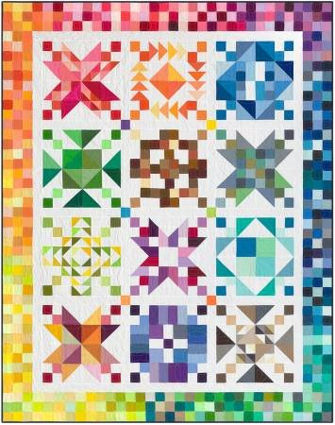
Color Patchwork Party Sew Along
Finished Size: Block: 16” X 16”
Quilt: 68”X 86”
Time: 10:00 AM – 2:00 PM
Place: Uptown Blanco Retreat House
514 3rd Street, Blanco
Cost: $10.00

Color Patchwork Party BOM was originally designed for solid colored fabrics, but we love small prints and using our stash fabrics! Each monthly block has a color theme, and each block finishes at 16" x 16". Adding a border makes the quilt 68" x 86". Victoria has already made our sample quilt using small prints and it's on display at the Studio.
Sew Along Required Supplies:
- Sewing Machine
- Sewing Notions (Pins, clips, thread, seam ripper, scissors, etc.)
- Monthly Block Pattern (Pick up from the Textile Studio prior to the sew along)
- Fabric for monthly block
Optional Sewing Supplies:
- Small cutting mat, ruler and rotary cutter
- Small mini iron and pressing mat
General Information:
- Bring your own lunch or plan on ordering from one of the local restaurants
(The Retreat House has a full kitchen)
- The Retreat House provides two ironing stations and two cutting stations

Here are the details for the program:
- Registration is $10 (plus tax) and you will be provided with the cutting overview and finishing directions
- Each month the fee is $6 (plus tax) and we will provide you with the block of the month pattern and one FQ in the "color of the month" fabric
- You can pick up the monthly BOM kit anytime of the month (after the first Tuesday), no need to stay for a presentation, or bring in your previous finished block, or come in on a certain day of the month, you choose when you pick it up
- Will we mail? Absolutely! Shipping will be about $3/month/package; we will need to have your credit card and mailing address on file
- If you miss a month or just can't make it into the Studio, you can pick up your kit at a later date
Once you get your FQ in the color of the month you can either use it in the block, or keep it for another project. Your block will need other fabrics and this is when you can either pull from your stash or buy more from us! Your choice!
To sign up for the program, come in to the Textile Studio or give us a call.
Uptown Blanco Textile Studio
830-833-1370
317 Main,
Blanco, Texas 78606

