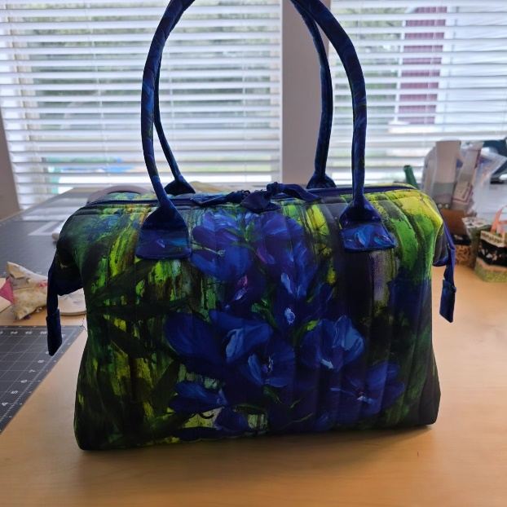
City Bag – Uptown, Midtown, or Downtown by Aunties Two Patterns
2-Day Workshop
Time: 9:00 am – 4:30 pm on both days (as needed)
Place: Uptown Blanco Retreat House, 514 3rd Street, Blanco
Instructor: Jeanette Krezwinski-Malone
Cost: $60.00
In this 2-day workshop you will be learning how to make one of the following City Bags from Aunties Two Patterns. You choose either the Uptown, Midtown or Downtown bag for your project. Uptown Blanco Textile Studio will be selling kits for each bag size which will include the pattern, metal stays, Bosal and Craft-tex required for the project. A 10% discount will apply to the kits for students in the workshop. Please cut your fabrics per the instructions on pages 1 and 2 of the pattern (not the Bosal) before coming to the workshop.
Uptown Bag Fabric Requirements:
Outer Fabric
- 1 Yard of non-directional fabric
- Or a large panel 43” square
Inside Fabric (Use non-directional):
- 2 ¾ yards (lining, pockets, pocket lining, handles, bottom, binding, bows, tabs)

Midtown Bag Fabric Requirements:
Outer Fabric (A)
- ¾ Yard of non-directional fabric
Inside Fabric (B - Use non-directional):
- 1 1/8 yards (Bag body lining, pockets, pocket lining)
Fabric C (Finishing):
- 5/8 yard (handles, bottom, binding, bows, tabs)

Downtown Bag Fabric Requirements:
Outer Fabric (A)
- 5/8 Yard of non-directional fabric
Inside Fabric (B - Use non-directional):
- 1 yard (lining, pockets, pocket lining)
Fabric C (Finishing):
- ½ yard (handles, bottom, binding, bows, tabs)
Required Sewing Supplies for all three bags:
- Pattern for either the Uptown, Midtown or Downtown bags (stays are included in the pattern and sold at Uptown Studio)
- Bosal (Unique Fusible Foam Stabilizer and sold by the yard at the Uptown Studio – 1 ½ yard for Uptown, 1 yard for Midtown and ½ yard for Downtown)
- Craf-Tex Plus (Double-sided fusible stiff interfacing and available by the yard at Uptown Studio each pattern size calls for ½ yard)
- Zipper (24” for Downtown and Midtown bag and 30” for Uptown bag)
- Sewing machine (with a walking foot and a free arm, zipper foot)
- Sewing machine thread to match fabric
- Sewing Machine Needles 90/14
- Rotary cutter
- Scissors, both large and small
- Chalk or Frixion pen
- Parchment paper or Teflon sheet for pressing
- Regular pins
- 24” ruler
- Pins
- Seam Ripper
Recommended but not required:
- Applique pressing sheet
- Fasturn #6 (for handles)
- G-easy Large clips
General Information:
- A 10% discount will be provided for supplies purchased on the day of the workshop.
- A lunch break will be provided, bring your own lunch or plan on ordering from one of the local restaurants.
- The Retreat House provides ironing and cutting stations.

