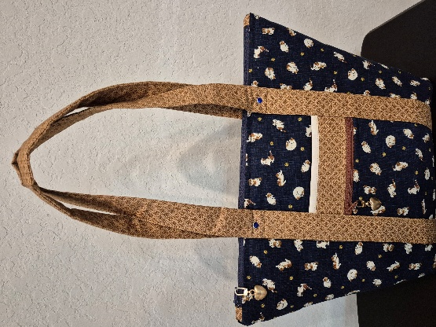
Carry All Tote Workshop
Finished Size: 15.5” X 11” X 5”
Time: 10:00 am – 5:00 pm
Place: Uptown Blanco Retreat House, 514 3rd Street, Blanco
Instructor: Tracey Puig
Cost: $50.00
The Carry All Tote is a great bag for shopping, travel, or just makes a great everyday tote. The tote has great organization with lots of pockets with a 14” top zippered opening. Three outside pockets keeps phone, keys, and other important items within easy reach. Fully lined tote interior has four large slip pockets plus one large zippered pocket for security. 1" wide shoulder straps can be carried comfortably on your shoulder. The pattern includes instructions for two different hand strap options - with or without decorative piping.
Pattern is required for workshop and is available for purchase/download prior to the class from mergefabricandcrafts. Instructions for pre-cutting the fabric prior to class will be sent once you have signed up for the workshop.
The Carry All Tote information:
Size finishes at 15.5" top width X 11" bottom width x 11" height x 5" Depth
10" strap drop length
3 exterior tote pockets at 5" X 6”, 5” X 7” & 5”X 8”
4 interior slip pockets at 6" width X 6" height
1 interior zippered pocket at 6" width X 6" height
Fabric Requirements:
- 1.5 yards main fabric (45" width)
- 1 yard lining fabric (45" width)
- Optional 1 1/2 yard fabric for interior pockets, exterior pockets and handles if you want them a different color than your lining.

Required Supplies:
- Sewing Machine
- Thread to match your fabric(s)
- Pins and clips
- Glue Stick
- Freezer Paper
- 2 1/2 yards fusible interfacing (Pellon SF 101)
- 1/2 yard fusible fleece (Pellon 987F)
- 14" main polyester zipper (or longer)
- 6" polyester zipper for exterior front pocket (or longer)
- 6" polyester zipper for interior pocket (or longer)
- 6" x 12" stabilizer for tote bottom (Peltex 71F stabilizer used)

Recommended but not required:
- 4 double capped rivets with 5 mm posts for bag feet
- Walking foot (Nice but not necessary)
- Travel Iron

General Information:
- A 10% discount will be provided for supplies purchased for the workshop.
- A lunch break will be provided, bring your own lunch or plan on ordering from one of the local restaurants
- The Retreat House provides two ironing stations and two cutting stations.

